Full Proposal Template

Space based services / applications addressing COVID-19 outbreak

INTRODUCTION
This Full Proposal Template is a tool to help the tenderer to prepare a comprehensive Full Proposal responding to the AO “Space based services / applications addressing COVID-19 outbreak”.

Please note that the preparation of the Full Proposal can be started only upon confirmation by ESA that the corresponding Outline Proposal has been accepted.

Concerning the use of this template, please note the following styles and the related instructions:

- Material presented in this plain style is either suggested content for a Full Proposal, or describes the content to be inserted in the corresponding paragraph, as relevant. The suggested material may be adopted as is, or modified at the Tenderer’s discretion. It remains the responsibility of the Tenderer to ensure that all of the Agency’s requirements of the present Call for Proposals are properly addressed.

- This style is used to identify information that must be modified and/or completed by the Tenderer for the proposed activity. This supplementary information shall presented in plain typeface (i.e. not red) in the final version of the Full Proposal.
- This style is used for explanatory notes and guidance to help you to develop the Full Proposal content (e.g. to indicate a selection between mutually-exclusive options). This information should be removed from the final version of the Full Proposal.
- For the generation of Work Breakdown Structure, overall planning, Milestone Payment Plan and PSS cost forms, a tool in Excel called “MSP-PSS Tool” is available at: https://business.esa.int/space-covid-19

Use of this Full Proposal Template is mandatory. The Tenderer shall not change the structure of this Full Proposal Template (i.e. the table of contents must remain unchanged).
The Full Proposal is the only document that will be considered by the ESA Tender Evaluation Board.
Please remove this and the previous page in the Full Proposal you will submit to ESA.
The length of the completed Full Proposal without Annexes shall not exceed 70 pages (without changing font size or page margins).

Delegations may require to access the full proposal to grant their Authorisation of Funding (AoF). Please timely coordinate with the relevant delegation(s) about the applicable process.

Space based services / applications addressing COVID-19 outbreak

MapCV19
OurLittleComp SrL

Full Proposal

Date: 03/04/2020
Reference: CM/020/Prop_001

INTRODUCTION 1
A. COVER LETTER 3
B. SERVICE VALUE PROPOSITION 4
B.1 Service Description and Selling Point(s) 4
B.2 Customer Segments 4
B.3 Key Resources and Partners 5
C. TECHNICAL PROPOSAL 6
C.1 Space Asset(s) and Rationale 6
C.2 System / Service Architecture 6
C.3 Implementation Approach 7
C.4 Pilot Service 8
C.5 Letters of Participation by Users and Other Stakeholders 9
D. Management and Administrative Proposal 9
D.1 Background experience 9
D.2 Organisation and management 10
D.3 Facilities 10
D.4 Key personnel 10
D.5 Monthly Progress Reports 11
D.6 Minutes of Meetings 11
D.7 Project Web Page 11
D.8 CV of Key Personnel 12
E. IMPLEMENTATION Proposal 13
E.1 List of Deliverables 13
E.2 Work Breakdown Structure (WBS) 15
E.3 Work Package Descriptions (WPDs) 16
E.4 Planning 18
F. FINANCIAL Proposal 20
F.1 Cost and Price Summary 20
F.2 PSS Forms 20
F.3 ANNEX PSS Forms 23
F.4 Source of the Entity Contribution 31
F.5 Statement of Profit 31
F.6 Currency and Conversion Rates 31
F.7 Type of Price 32
F.8 Quotations Free of Taxes and Customs Duties 32
F.9 Milestone Payment Plan 32
G. CONTRACTUAL Proposal 37
G.1 Compliance with the Contract Conditions 37
G.2 Insurance Waiver 38
G.3 Statement Relating to Export Import Licences / Authorisations and Related Documentation 38
Annex 39

COVER LETTER
THE COVER LETTER IS PROVIDED AS A SEPARATE DOCUMENT

SERVICE VALUE PROPOSITION

Service Description and Selling Point(s)

The proposed activity addresses the following topic: Healthcare or Education

Provide a description of the product / service you intend to offer

Describe the innovation / key selling point(s) with respect to what is available in the market

How does the proposed final product / service fit within your current business activities and your mid-/long-term strategy?

What is the relevance to the call objectives? Which topic and application area(s) do you propose to address? How will the proposed service ease the challenges faced by the user community?

Customer Segments
The key user/customer segments targeted by our product / service are: ……

The pains (e.g. problems) and gains (e.g. benefits) are: ……

The potential customers already identified are: ……

The following table provides a summary overview of the users/ customers, their current problems and the associated value proposition, i.e. the value that the product or service offers to these users/customers.

Table B.1 Key User/Customer Segments, their Needs and Value Proposition
Key User/ Customer Segments | Problems/Needs | Value proposition
……… | ……… | ………
……… | ……… | ………
……… | ……… | ………

Our relationships with the key customers already exist / must be created / have to be improved.

Key Resources and Partners

To implement our product / service and deliver the value propositions we need the critical resources that are defined in the following table, as applicable.

Table B.2 Key Resources
Required Resource | In Place | Potential Issues
……… | yes/no | ………
……… | yes/no | ………
……… | yes/no | ………
Resources could include, for example, assets, company competences, money, manpower, know-how / expertise, key suppliers, consultancy service, and manufacturing, test or other facilities. Indicate whether or not the resources are expected to be in place at the time of need. If not, explain the actions to be taken to secure their availability on time. Indicate potential issues associated with each key resource. These could include, for example, long lead items, software licensing, patent constraints, procurement policies and national/international restrictions (e.g. export restrictions), relevant regulatory frameworks.

The value chain involves the key partners defined in the table below.

Table B.5 Key Partners
Partner Name  (company name, country, web link) | Background / Experience | Involvement in the Project and/or in commercial exploitation  (e.g. none, subcontractor, supplier, pilot user, customer, integrator)
……… | ……… | ………
……… | ……… | ………
……… | ……… | ………

Please, take into account that partners during the project stage may not be the same as during exploitation (e.g. HW factory producing the designed product may not have a role during the project, but it will be necessary during exploitation). Please explain the status of those relationships (existing, in progress, to be established…) complementary to the info of the table above.
The following diagram describes the project partners and their role in the project and in the commercial exploitation stage of the product / service.

Figure B.1 Project Team Composition and Roles
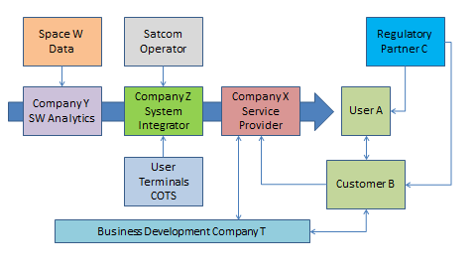

TECHNICAL PROPOSAL

Space Asset(s) and Rationale

Describe space technology / space asset(s) intended to be used, and rationale

System / Service Architecture
A high level block diagram of the system / service showing the key attributes and key building blocks and the main interfaces is provided in Figure E.1.

Figure E.1 System/service Architecture
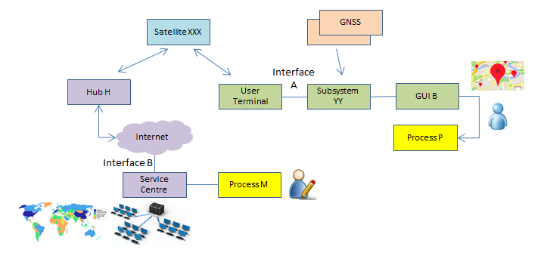
EXAMPLE

Provide a short description of the building blocks and their maturity, e.g. The individual building blocks, their maturity (COTS, existing, to be enhanced, to be developed), their main features as well as the interfaces between the building blocks are the following:
Building block “aaa”: …
Building block “bbb”: …

Implementation Approach

The expected goals / outputs at the end of the proposed activity and the way they will contribute to the final product / service are: ……

The starting point for our project (in terms of existing elements, building blocks, systems, relationships, etc.) is: ……

The elements to be developed in the proposed activities are ……

The key activities proposed to be executed are reported in the table below:

Table E.2 Overview of Key Activities
Key Activity | Description | When are going to be performed (during or after the project)
……… | ……… | ………
……… | ……… | ………
……… | ……… | ………

The expected goals / outputs at the end of the activity and the way they will contribute to the final product / service are: ……

The deployment of the services will be carried out with the following planning (indicate if the services are expected to respond to the current challenges of the emergency due to the spread of the virus and or if the services will support the communities in medium-long term)

Our proposed development approach is the following: …… (describe the source of the key building blocks, such as existing elements and/or all items to be developed, integration with the existing environments and workflows). This will result in the following hardware / software models to be built, verified and delivered: fully operational prototype, alpha product, pre-operational service.
The overall service development approach is the following: …….

Pilot Service
The pilot service has the following objectives …….

We will assess the success of the demo project based on the following KPIs (please, present at least one KPI per objective) …….

The pilot service activities will be based on the following undertakings: users/customers involvement, envisaged utilisation of the system, e.g. 2 hours of use every day, duration of the pilot stage e.g. 8 months, etc.

Describe the space asset(s) that will be used in the pilot (type, justification, major elements such as data or services to be procured)

The expected preparation activities of the pilot will include: specify as needed. e.g. deployment, integration within the user environment, acceptance, logistics, training.

The pilot will take place in … [country] in the following location (e.g. hospital, school, medical centre) ………. and it will start at … not later than 3 months after the kick-off--and it will last at least ….. not less than 2 months.

The customers/users/stakeholders participating in the pilot, the related level of involvement and a short description of the activities to be performed by them is summarised in the table below.

Table E.1 Involvement of Users, Customers and Other Stakeholders in the Pilot
User / Customer / Stakeholder | Role in the Pilot | Activities | Agreement and associated status (in place, to be secured in Full Proposal, etc.)
……… | ……… | ……… | In place / in Full Proposal…
……… | ……… | ……… | In place / in Full Proposal…
……… | ……… | ……… | In place / in Full Proposal…

During the pilot, the activities will be reported according to the guidelines provided in the Pilot Operations Summary Report (link).

Letters of Participation by Users and Other Stakeholders
The users, customers and other stakeholders involved in the proposed project have issued statements confirming their participation in the pilot application and indicating their interest in the proposed service(s). These statements are attached as Annex G to this Full Proposal.

Management and Administrative Proposal

Background experience
Presentation of the Tenderer / Subcontractor(s) and their organisational structure (e.g. key company details, turnover, ownership…).

Background description and relevant experience of the tenderer, subcontractors, users, partners (if applicable).

Organisation and management
Presentation of the project team and of the structure of the project organisation (including users / stakeholders), and where it is proposed to subcontract part of the work, the structure of the industrial group. Include identification of the nominated Project Manager and Contractual Manager, both should usually belong to the organisation of the Prime Contractor.

Lines of communication and reporting, and means for settling disagreements.

Facilities
Description of all facilities to be used including those facilities which are still to be developed / built and / or purchased, with a statement on whether the costs of developing / building / purchasing the facility are to be directly or indirectly charged to the Contract. Modifications to existing facilities are also to be described. For this purpose, facilities may include, as applicable, hardware, computer software, manufacturing equipment, test equipment, production and integration lines, service centres and infrastructures hosting the user communities.

Description of means of access to space assets and space based services as relevant, information resources such as libraries, databases, the company has, if these are required for the work proposed.

Key personnel
Key personnel are identified as persons who, because of their individual qualifications and positions are proposed for the work and indicated as such in the tenderer's Organisation Breakdown Structure. As a minimum, each person assigned as Work Package Manager shall be nominated as Key Personnel. Key representative(s) of the customers/users shall also be presented.

The following table provides an overview of the allocation of the Key Personnel to the proposed activities.

Table D.1 Key Personnel

Full Proposal Template | Role in the Project | Company | Manager of WP(s) | WP(s) allocation in h | Average allocation of time for the duration of the project (1700 h/year)
Mario Primi | Indicate role | Prime | WP1100, WP1200, WP2200 | WP1100(800) WP1200(840) WP2100(850) WP2200(860) | 51%
Luca Secondi | Indicate role | Prime | WP2100, WP3100 | WP2100(40) WP3100(100) WP3200(120) WP4100(320) WP4200(355) | 21%
Franca Terzi | Indicate role | Subcontractor A | WP3200 | WP3200(70) | 4%
Luigi Quarti | Indicate role | Subcontractor B | WP4100 | WP4100(120) | 7%
Elena Quinti | Indicate role | Subcontractor B | WP4200 | WP4200(130) | 8%

The CVs for all key personnel are provided in Par.D.7. Each CV provides:
- a summary of the work experience of the person concerned;
- a brief description of their present job and responsibilities;
- their specific qualifications and experience of direct relevance to their role in the project.

Monthly Progress Reports
A concise monthly progress report will be provided to the Agency within the first five working days of each month. The template available in the Business Applications web site, section “documents” will be used.

Minutes of Meetings
Each review meeting will be organised using the Draft Agenda available in the Business Applications web site. Formal written minutes of meetings attended by the Agency will be agreed and will be signed and made available to the Agency at the end of the meeting.

The minutes will, as a minimum, identify all agreements made and actions accepted during the meeting.

The following identification scheme will be used to define the Action Items:
Action X.Y
where X is the identifier of the meeting (0: Negotiation Meeting, 1: First Review Meeting, 2: Second Review Meeting, etc.), and Y is the Action number starting from 1 at each new meeting.

All Actions Items will be recorded in the Distributed Project Collaboration Tool made available by ESA, and the associated status will be kept up-to-date by the Project Manager.

Project Web Page
A first version of the project web page will be produced as part of the deliverable documentation package for the BDR using the latest template specified by the Agency.

The project web page will be updated periodically during the development so that the project and its current status are properly portrayed.

The final version of the project web page will be provided to the Agency together with the final version of the Final Report. It will include a paragraph summarising the most significant achievements of the project.

CV of Key Personnel

Curricula Vitae of the Key Personnel

Provide completed CVs for all members of the key personnel using the following template, or equivalent. Competence in technical, business development, market expert or insider, commercial and sales shall be explicitly presented.

Name
Specific Qualifications and Experience Relevant to the Project Role: | …
Entity: | …
Present Position and Responsibilities in the Entity: | …
Education:
Year(s) | Educational details
Year(s) | Educational details
Work Experience:
Year(s) | Entity, Project, Position, Responsibilities, Achievements
Year(s) | …
Year(s) | …

IMPLEMENTATION Proposal

List of Deliverables

The documents that will be delivered during the project are summarised in the table below.

Table E.1 Deliverable documents
Name | Deliverable | Initial Submission | Final Submission
PBC | Project Bar Chart | with the proposal
MOM | Minutes of Meetings | NM | FR
RD | Requirements Document | DR | FR
SSA | System and Service Architecture | with the proposal | FR
PilUP | Pilot Utilisation Plan | with the proposal | FR
SVD | System Verification Document | CDR | AT
PWP | Project Web Page | BDR | FR
FREP | Final Report | FR
FDP | Final Data Package | FR
S&A | Summary and Achievements | FR

Each deliverable document will include a title page reporting the project name, the contract number, the title of the document, a reference identifier, the author(s) and related organisation(s), the date of issue and the revision number.

All deliverable documents will include a record of the document history, indicating in short for each document revision the corresponding date and the reason(s) for the revision. The relevant copyright marking in line with the contract provisions shall be clearly identified.

All deliverable documents will be delivered using the Agency’s web-based project planning and collaboration tool. Documents will be delivered at least five working days prior to the associated review.

The following table describe the list of Hardware and Software and associated Documentation that will be delivered to ESA as part of the proposed project.

Table E.2 Deliverable Items
Entries in the table are just examples to be amended as relevant
Type | ID | Item description | Number of Items | Deliverable Point | Notes
Portable  Demonstrator (when practical) | PD | ……… |  | ESA | Self-contained setup to support visual presentation of the product / service to non-expert people
Hardware | HW.01 | Satcom user terminal | 6 | User sites A, B, … | 80 cm dish…
 | HW.02 | Handheld tablet | 8 | User sites c, d, … | Model….
 | HW.03 | Server | 1 | Service centre | Model ....
 | HW.04 | Portable Demonstrator | 1 | To ESA at the FR | ………
 | ……… | ……… | ……… |  | ………
Software(*) | SW.01 | M&C Fleet | 1 | Service centre | ………
 | SW.02 | Mobile App | 8 |  | Embedded in HW.02
 | ……… | ……… | ……… |  | ………
Manuals | DOC.01 | User manual | 8 | Together with HW.02 | ………
 | DOC.02 | Service Centre Installation | 1 | Together with HW.03 | ………
 | ……… | ……… | ……… |  | ………

Please note that the Hardware (listed above) shall only include the items fully costed to the project.
Hardware procured and charged under an amortisation scheme (e.g. two years use of a server with a five years lifetime) are not project deliverables, but shall be itemised in the Exhibit A of the PSS-A2 forms.
(*) Delivery of the Software will be performed by storing the SW modules and versions developed under the project in a secure software repository (on-site or in the cloud). Up to two years after the contract closure date, ESA will be provided access to the repository by contacting the Project Manager.

Work Breakdown Structure (WBS)

A tool in excel called “MSP-PSS Tool” is available at: https://business.esa.int/documents for the generation of Work Breakdown Structure, overall planning, Milestone Payment Plan and PSS forms compilation.

The figure below presents the work breakdown structure, covering the entire scope of the proposed work.
Replace the following diagram with an equivalent showing the proposed work breakdown structure; provide at least two levels. Entries in the table are just examples to be amended as relevant
Figure E.3 Work Breakdown Structure

Work Package Descriptions (WPDs)

A work package description form (PSS-A20) is presented herewith below for each of the work packages at the lowest level of the work breakdown structure.
In general, in case the WBS is based on two levels WPs, the WPDs will refer only to the second level WPs, and the first WPs will not be associated to any WPD.

The work package descriptions comply with the following requirements:
- There is a single work package manager for each work package, who is a member of the key personnel.
- Work packages start and end on milestone events and do not span the entire duration of the activity (except for the project management work package and the closely associated management functions).
- Inputs from other work packages are clearly identified.
- The work to be performed is described in sufficient detail for the Agency to be able to judge the value for money, including scope of work and man-hours.
- Each task is traceable with a corresponding work package output.
- Each work package has at least one traceable work package output (hardware, software and/or documentation item, deliverable to the Agency).
- All deliverable hardware, software and documentation items are traceable to the identified work packages.

Provide completed work package descriptions for each work package identified in the work breakdown structure. Entries in the table are just examples to be amended as relevant

PROJECT: Project Name PHASE: N.A. | WP: 1100
WP Title: Pr. Management  Company: Prime  WP Manager: Project Manager Name  Start Event: KOM Planned Date: To  End Event: FR Planned Date: To+24m | Sheet 1 of 1  Issue Ref …  Issue Date …
Inputs:
- Project Proposal
- IAP Management Requirements for IAP Demo Projects, v.X.Y
…

Tasks:
- Coordinate activities with Subcontractors
- Liaise with ESA
- Quality Control of Deliverables
…

Outputs:
- Minutes of Review Meetings
- Monthly Progress Report
- Project Web Page
- Final Report
- Summary and Achievements
…

Planning
The GANNT chart below is just a simple explicative example

FINANCIAL Proposal

Cost and Price Summary

The cost and price for the project is as defined in the following table.

Figure F.1 Cost and Price Summary
Entity | Country  (ISO Code) | Role | Cost in Euro | Price in Euro
Tenderer | … | Prime | €…,… | €…,…
Subcontractor 1 | … | Subcontractor | €…,… | €…,…
Subcontractor 2 | … | Subcontractor | €…,… | €…,…
… | … | … | … | …
 |  | Total: | €…,… | €…,…  (…% of total cost)
[When mentioning the Price of the activity, please, refer to the amount to be funded by ESA. The total cost of the activity is the complete activity cost composed of the ESA funding (firm fixed price to ESA) and the company’s contribution.

Figure F.2 External Service Providers
Service Provider | Country  (ISO Code) | Charged to Entity | Nature of the service | Cost Breakdown in Euro | Cost in Euro
Service Provider 1 | … | Prime | … | Number of units, €/unit €…,… | €…,…
Service Provider 2 | … | Subcontractor 1 | … | €…,… | €…,…
Service Provider 3 | … | Subcontractor 1 | … | €…,… | €…,…
… | … | … | … | … | …
Costs related to marketing activities (PR material, participation in conferences, exhibitions, etc.) are eligible up to 3% of the total cost.]

PSS Forms

The PSS forms are attached in Annex PSS Forms for the Tenderer and for each of the proposed Subcontractor(s), showing, per entity, the total cost of the proposed work (i.e. including the entity’s share):
PSS-A1;
PSS-A2 (including Exhibits A and B, where applicable);
PSS A8 (reflecting the lowest level of the WPDs);
PSS A15-1.

The PSS forms in Excel format can be downloaded from EMITS, Reference Documentation > Administrative Documents > PSS Forms. The PSS Forms shall be signed (in particular the PSS-A1 and A2) by an authorised representative of the relevant contractors (Prime and each subcontractor, as relevant). Insert in this template the scanned PSS-A1 and PSS-A2 forms signed.

Notes for the compilation of the PSS Forms:
- PSS-A1 shall include the validity period covering the full duration of the project
- PSS-A2 shall include Exhibit A (other direct cost elements) and Exhibit B (travel plan and cost detail)
- In order to facilitate the participation of the key users to major projects reviews (typically, BDR and FR), travel costs incurred by users can also be included in the project costs
- Contributions from users and/or other stakeholder(s) can be recognised as allowable cost of the project. These contributions must be restricted exclusively to the demonstration project supported by ESA. They must be recorded in the PSS-A2 form(s) of the Tenderer (or its Subcontractor, where applicable) under “OTHER COST ELEMENTS”, and be further detailed in a letter of support signed by the user or stakeholder and in the Exhibit A of the relevant PSS A2 form, indicating the number of hours and hourly rates, facilities (if any) and the WP number(s) to which the users/stakeholder contributes
- All hardware, software and or services procured for the project shall be listed in the PSS-A2 under the voice 3.6-External Major Products (for hardware and software) and 3.7-External Services (for services). These costs shall be broken down detailing each single cost element in the Exhibit A of the PSS-A2, indicating the number of units and the total costs. The cost elements detailed in exhibit A shall be self-explanatory
- Hardware and software whose use is not limited to the demonstration project shall be amortised over its lifetime and only the period (months) in which they will be used for the project shall be listed as eligible project costs
- All hardware, software whose cumulative value exceed 10.000 Euro shall be provided with details of the procurement source (Name of the company and country)
- All external services whose cumulative value exceed 10.000 Euro shall be provided with details of the procurement source (Name of the company, country, number of man hours quoted and rate/hour, detailing any major additional cost item quoted in the service)
- If the country of procurement of hardware, software and/or external services is different from the one of the company that is procuring them, an approval of the National Delegation of the country may be required. It is duty of the prime contractor to inform the National Delegation of the intention to procure the item outside the country of origin and seeking for its approval
- PSS-A8 shall be compiled taking into account the WPs for which a WPD does exist. Typically, if the WBS is structured with a two levels WPs, the PSS-A8 shall refer to the WPs of Level 2, e.g. WP1100, WP1200, .., WP2100, WP2200, …
- PSS_A15 shall show the full cost profile of the company disbursement, and the payments received
from ESA (e.g. 50% of the project costs) reflected in the Milestone Payment Plan; the advance payment shall not be recorded

ANNEX PSS Forms

PSS-A1;
PSS-A2 (including Exhibits A and B);
PSS A8;
PSS A15.1.

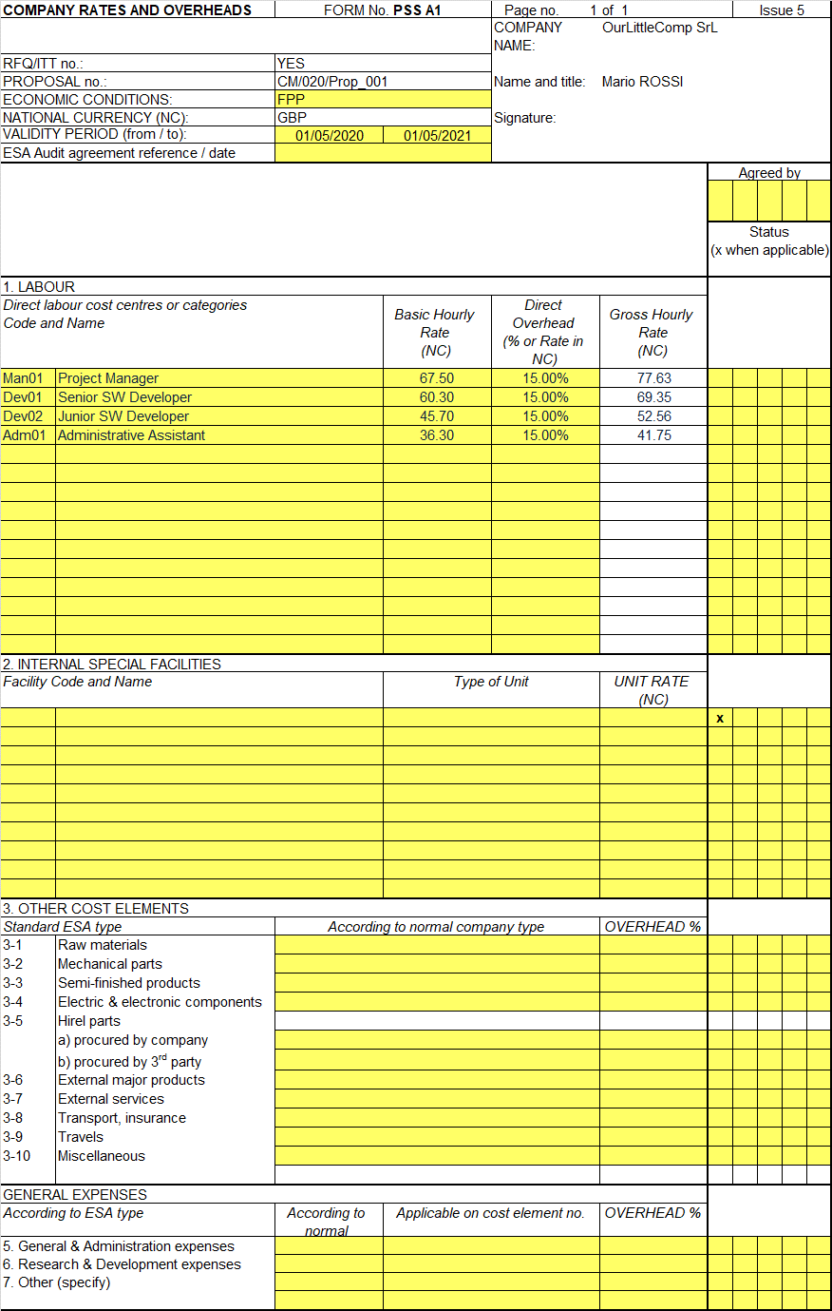
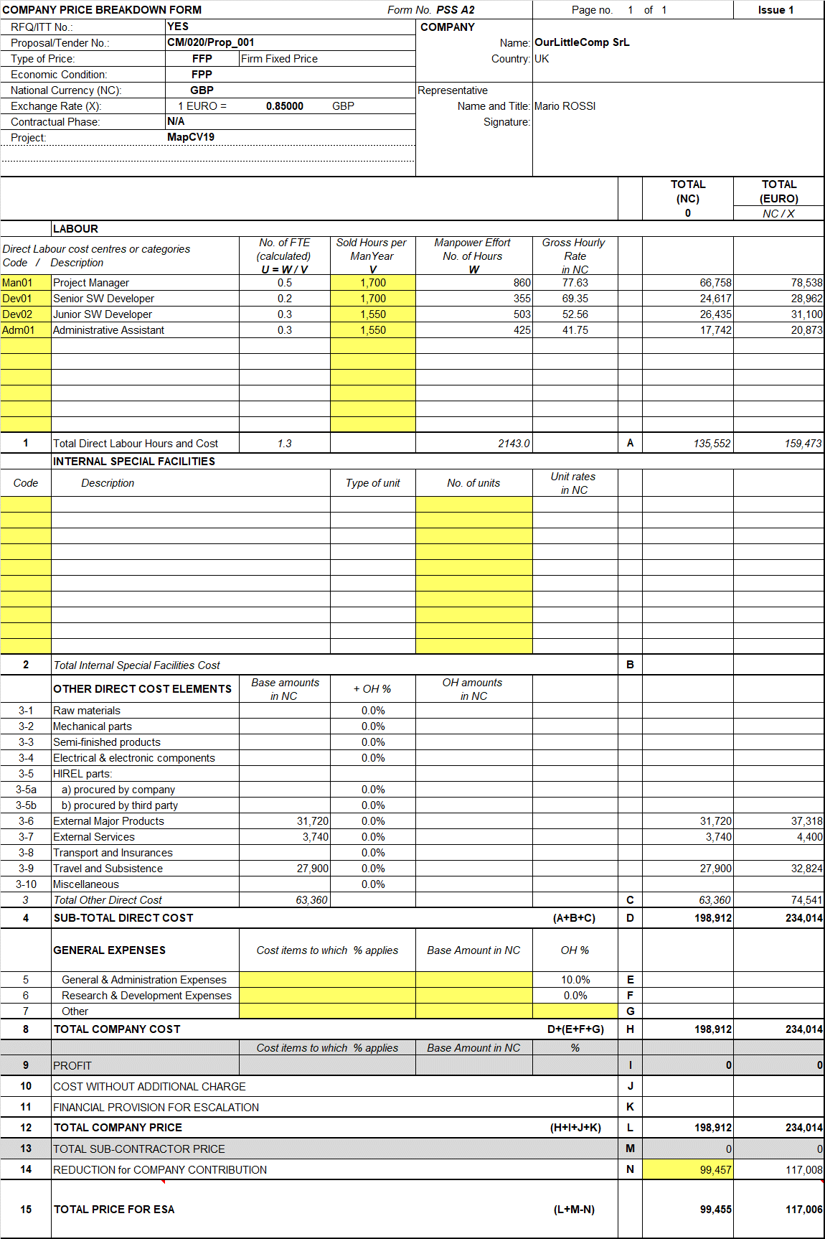
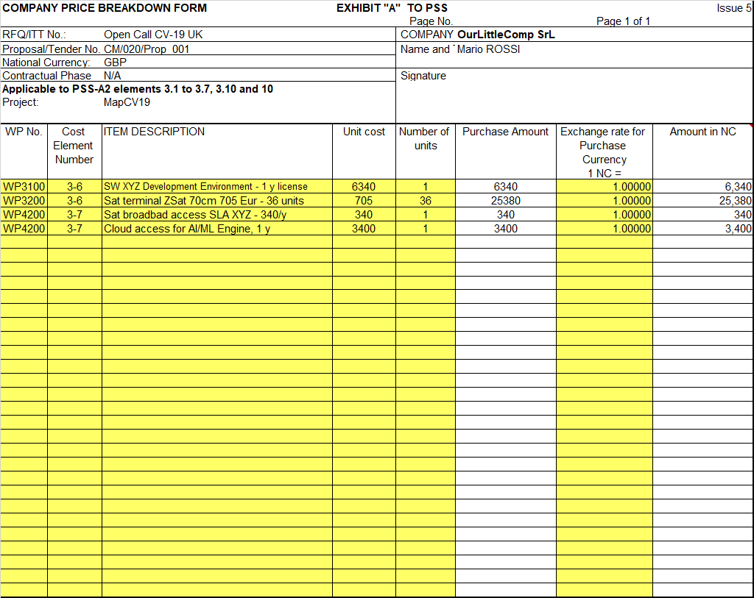

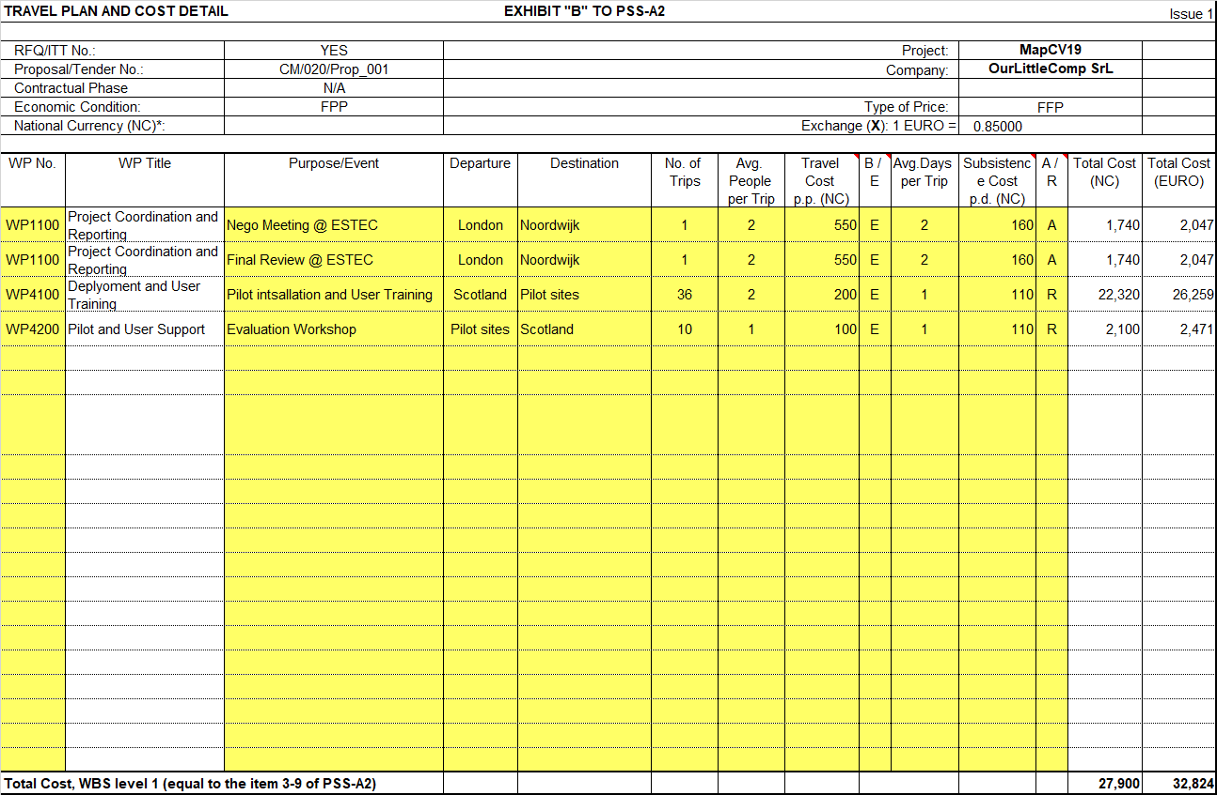

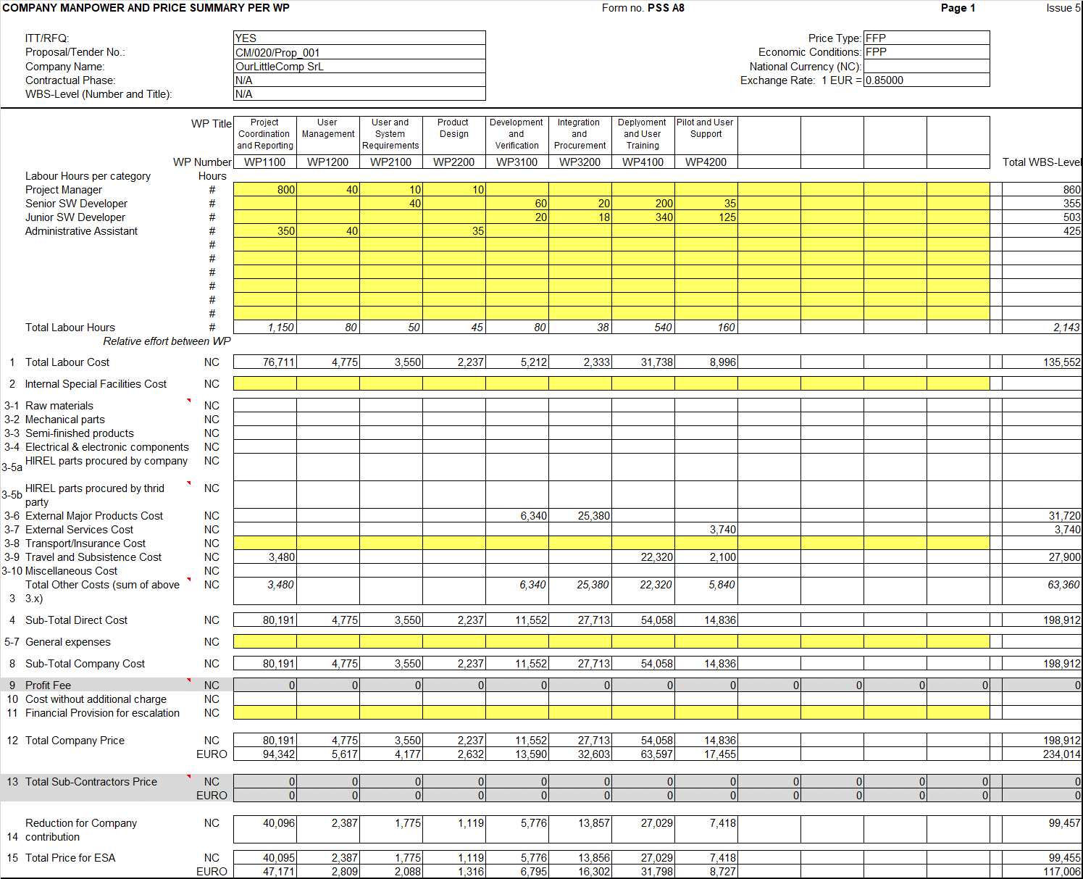

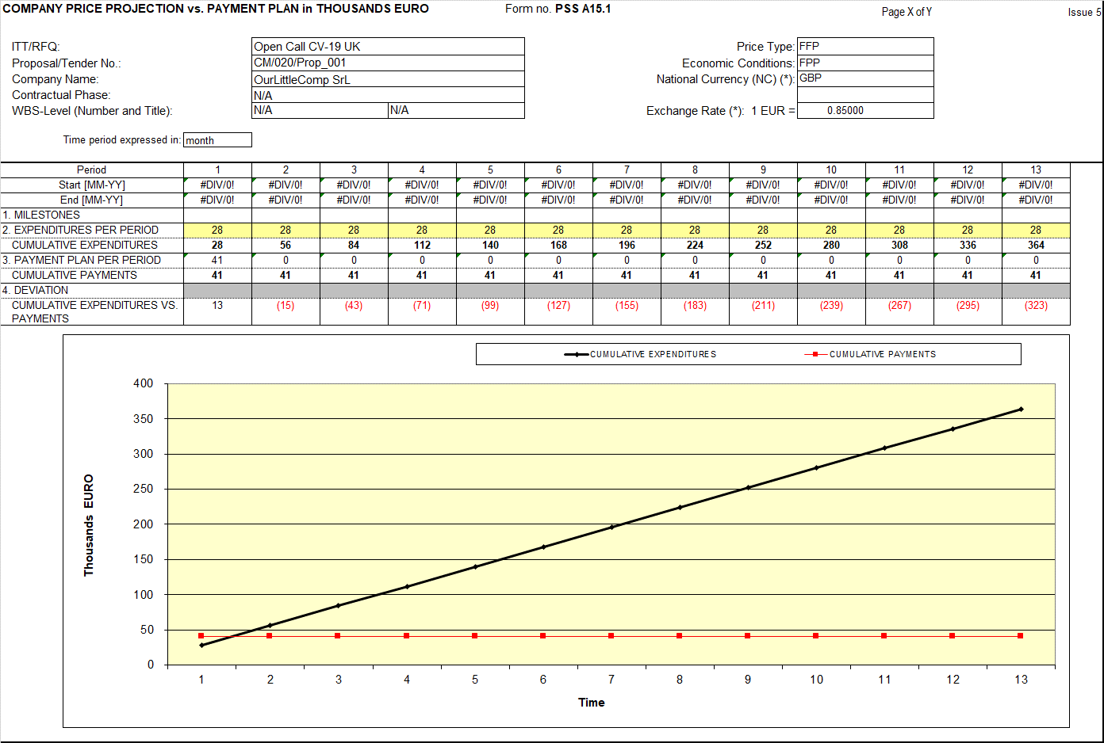

Source of the Entity Contribution
The source of the entity contribution (including from any private third party) to the overall development costs is as follows:
Tenderer name (tenderer): ….
Candidate Subcontractor 1 name (subcontractor): …….
Candidate Subcontractor …. name (subcontractor): …….

It is confirmed that, in all cases, the entity contribution excludes:
overheads included in rates charged to the Agency for the contract, or any other contract with the Agency, or sub-contract awarded under an Agency contract
Examples of possible sources of co-funding are: existing funds in bank account coming from sales/profit, already approved/prospective bank loan, investment from external source e.g. private investment funds, other contributions. EU and/or national funds coming from e.g. R&D programmes are not allowed.
The purpose of this information is to provide evidence on the capabilities of the involved company(ies) to pay their share of the cost of the proposed activity elements (procurements, facilities, manpower) and, as such, can serve the obligations of the activity.
The bidder(s) is(are) kindly invited to provide evidence of the co-funding in the form of a letter(s) of commitment from investor(s), bank guarantee(s), loan(s) or own resources (e.g. cash and other liquidity).

Statement of Profit
This financial offer is exclusive of profit.

Currency and Conversion Rates
This financial proposal is presented in Euro.
All members of the Bidding Team are located in countries participating in the Euro, so no currency exchange rates are applicable.
or include and complete the following information for all members of the Bidding Team located in countries not participating in the Euro.

The following table identifies the entities within the Bidding Team who are not located in countries participating in the Euro and the currency exchange rates that have been applied in each case.
This exchange rate shall be stated in the PSS forms and shall be clearly explained in Exhibit A to form PSS-A2. Any other factors (e.g. hedging costs, forward buying rates, etc.) used for the purpose of its calculation shall be indicated.

Table F.6.2 Summary of exchange rates applied
Summary of exchange rates applied
Entity | National Currency | Exchange Rates Applied | Detailed in the Entity’s PSS-A2 Form and its Exhibit A | Other Factors Used to Calculate the Exchange Rates
… | … | … | yes/no | …
… | … | … | yes/no | …
… | … | … | yes/no | …
… | … | … | yes/no | …

Should any country(ies) to which the above entity/entities belong adopt the Euro following the submission of proposals, the applicable conversion rates shall be the ones then adopted by the appropriate European Authorities.

Type of Price
The price quoted is a Firm Fixed Price.

Quotations Free of Taxes and Customs Duties
The price quoted is free of taxes and customs duties.
or
We believe that we cannot obtain exemption from tax or customs duties because ……. Consequently, we consider that we will remain subject to the payment of taxes or customs duties under the conditions indicated below:
Applicable rates: | ……
Estimated total tax amount: | ……
Estimated total customs duty amount: | ……

Milestone Payment Plan
The proposed milestone payment plan is detailed in the tables below. It is based on the information provided in for PSS-A15.1 and reflects the economic reality of the project.
The proposed payment plan shall take into account Article 3 of the Draft Contract and the following provisions:
- All claims for payment shall be linked to the achievement of defined schedule milestones
- These milestones are to be in the form of significant events in the programme, to be selected on the basis of providing a check point for progress of the work performed
- The payment plan shall consist of progress and final payment milestones only, adding up to the total contract price
- The final payment shall not be less than 15% of the total contract price also taking into account any offsetting of the Advance Payment(s) amount

Table F.9.1 Milestone Payment Plan

Milestone Description | Schedule Date | Amount in EUR | Country  (ISO Code)
MS1- Upon successful DR Review and the Agency’s acceptance of all related deliverables | 30/06/2020 | 110,952 | UK
MS2- Upon successful AT Review and the Agency’s acceptance of all related deliverables | 30/08/2020 | 95,102
MS3- Upon successful FR Review and the Agency’s acceptance of all related deliverables | 01/05/2021 | 110,952
Total |  | 317,006

Payment plans for Prime and Subcos
Milestone | Prime (UK) | Subcontractor A (UK) | Subcontractor B (UK)
MS1 - DR | 40,952 | 26,250 | 43,750
MS2 - AT | 35,102 | 22,500 | 37,500
MS3 - FR | 40,952 | 26,250 | 43,750
Total | 117,006 | 75,000 | 125,000

Include the following explanatory text and table if you wish to propose an advance payment plan.
The advance payment shall take into account Article 3 of the Draft Contract and the following provisions:
- An advance payment is not granted automatically, it is required to demonstrate a significant need for cash disbursement at the beginning of the execution of the contract.
- The amount of any proposed advance payment and the corresponding amount(s) to be offset against the relevant milestone payment(s) shall be clearly stated in Euro, along with a justification for the need for cash disbursement at the beginning of the execution of the contract. Nevertheless, whenever an SME (as per definition in http://eur-lex.europa.eu/legal-content/EN/TXT/PDF/?uri=CELEX:32003H0361&from=EN) is involved as prime or subcontractor, it shall be entitled to a 35% advance payment irrespective of any cash disbursement needs. Further, the SME has the right to request the offset of the 35% advance at the end of the contract i.e. the two last milestones (ideally 25% at the last milestone and 10% at the preceding milestone), if this can be justified in view of the economic progress in the contract.

[if needed]: An advance payment is proposed in the table below. his proposal reflects the need for significant cash disbursement at the beginning of the activity, as shown in the cash flow profile presented in form PSS-A15.1.

[in case of no SME involved]: The reasons for this early cash disbursement are …….

Table F.9.2 Advance payment(s) and other financial conditions

Prime (P) / Subco (SI) | Company Name | Entity Code | Country  (ISO Code) | Advance Payment (in EUR) | Off-Set against | Off-set by (amount in EUR) | Condition for release of the Advance Payment (if applicable)
P | Prime |  | UK | 40,952 | MS1 - BDR | 0 | After signature of the Contract by both parties
 |  |  |  |  | MS2 - FAT | 17,551
 |  |  |  |  | MS3 - FR | 23,401
 |  |  |  |  | -
 |  |  |  |  | -
SI | Subcontractor A |  | UK | 26,250 | MS1 - BDR | 0 | After signature of the Contract by both parties
 |  |  |  |  | MS2 - FAT | 11,250
 |  |  |  |  | MS3 - FR | 15,000
 |  |  |  |  | -
 |  |  |  |  | -
SI | Subcontractor B |  | UK | 12,500 | MS1 - BDR | 12,500 | After signature of the Contract by both parties
 |  |  |  |  | MS2 - FAT | 0
 |  |  |  |  | MS3 - FR | 0
 |  |  |  |  | -
 |  |  |  |  | -

CONTRACTUAL Proposal

Compliance with the Contract Conditions

Tenderers are required to make use of the ‘smart contract’ tool. This tool consists of an Excel file where relevant contractual information can be inserted or options selected by the Tenderer. From the completed Excel table, a Word file of the draft contract can then be generated which incorporates the information provided. This updated draft contract is intended to provide the tenderer with a better understanding of the contract which would result from a successful tendering process. In case of successful evaluation, it will also expedite the completion of the contract on ESA side. The tool is also aimed at demonstrating full compliance with contractual provisions. In case, exceptionally, that contractual modifications or amendments are proposed, the full text of such modifications or amendments shall be given in this Section 1 and the reasons for requesting them shall be clearly explained.

Any proposed modifications or amendments to the Contract conditions will be taken into account in the evaluation.
Please be aware that not all provisions of the contract can be modified using the excel file. Guidance on how to use the tool can be found here:

https://emits.sso.esa.int/emits-doc/ESTEC/1-10336/TutorialSmartContractTenderer.pdf

The smart contract tool can be found here:

https://emits.sso.esa.int/emits-doc/ESTEC/1-10336/SmartContractTool_10336.zip

Please consult the "ReadMe" file first before completing the Tenderer section of the Excel table. Both the completed Excel table and the Word document generated as per the instructions in the "ReadMe" file should be included in the electronic version of your proposal. In case of successful evaluation and negotiation, the Agency will then need to complete the contract in the part of its competence and as relevant before releasing the contract for signature.

The completed Word and Excel files generated from the Smart Contract Tool are uploaded under the “Other” proposal element in esa-star.

The contract conditions have been read, are understood and accepted. No sales conditions of our own are applicable.

The Personal Data “Controller to Controller” (PDCC) Annex to the Contract has been read, are understood and accepted. It is understood that this Annex forms an integrated part of the Contract and that it will not be subject of separate signatures. Should the tender lead to a Contract award, the PDCC will enter into force upon signature of the Contract by both Parties.

Insurance Waiver
A waiver of subrogation rights from our insurer will be available at the time of contract signature.
or
A waiver of subrogation rights from our insurer will not be available. The hold harmless agreement specified in Clause 18.1.6 of the General Clauses and Conditions for ESA Contracts shall apply.

Statement Relating to Export Import Licences / Authorisations and Related Documentation
There are no export or import restriction issues and thus no need to obtain specific licences or authorisations.
or include and complete the following statements as appropriate
Export or import restrictions and/or a need of adequate licences or authorisations exist, and the status regarding such requirements is at present the following:
- the Tenderer/Subcontractor … (name) has obtained the following authorisation(s) in order to submit this tender: ….
and/or
- the Tenderer/Subcontractor … (name) will need to obtain, prior to the placing of a Contract, the following authorisation(s): ....
and/or
- the Tenderer/Subcontractor … (name) will need to obtain the following authorisation(s) for the implementation of the contract: ....

Annex
Statement from users, customers and other external partner organisation(s)

[Please, enclose a ‘Letter of Interest / Commitment’ for each participant (customer, user, other external partner organisation) not appearing explicitly as subcontractor, containing information on their motivation for their participation (in their own words) as well as information on their contributions to the various study tasks.
Contributions to the demo project may include:
  - challenges faced because of the coronavirus outbreak
  - support to definition of user scenarios/processes,
  - support to definition of user requirements,
  - identification of expected benefits and financial constraints,
  - support with validation of the Pilot,

