OUTLINE Proposal Template for IAP-5G for L’ART Feasibility Study

INTRODUCTION
The goal of the ARTES Integrated Applications Promotion (IAP) programme is to develop operational downstream applications and services using existing space technologies, integrated, when needed, with terrestrial solutions.
For this specific call, the bidder shall propose a Feasibility Study for developing space-based applications leveraging on the deployment of the latest generation of mobile communication (5G) in the L’ Aquila/Abruzzo Region and/or Roma Capitale and/or Torino region.

The Collaboration between ESA ARTES IAP and L’ART is underpinning this specific call for proposal titled” 5G for L’ ART”. This call for proposal targets activities:

- Assessing technical feasibility and commercial viability of future space-based downstream services
- Foreseeing the integration of 5G technologies and space asset(s)
- Performing a Proof of Concept (PoC) in at least one of the proposed L’ART region
- Addressing one of the proposed uses cases described in the Cover Letter.

An Outline Proposal is a means for the bidder to start a dialogue with the ARTES IAP team at the Agency (including some representatives of the L’Aquila/Abruzzo Region, Roma Capitale, Torino) on the content and justification of the planned activity.

The Tenderer is reminded that the ARTES IAP is an optional programme of the European Space Agency, and as such every activity has to explicitly receive the financial authorisation by the National Delegations of the relevant countries of the consortium. The Tenderer and its Subcontractor(s) shall therefore contact their National Delegations before submitting their Outline Proposal. Should the National Delegation(s) request access to the Outline Proposal, this shall be handled directly by the Tenderer and its Subcontractors and such National Delegation(s).

The Tenderer is required to submit an Outline Proposal containing the information described in this document before submitting a Full Proposal. On the basis of the information provided in the Outline Proposal, the eligibility of the proposed idea for ARTES IAP support will be assessed by relevant ESA and L’ART experts and early feedback will be provided. Only once the Outline Proposal is found acceptable by ESA, the Full Proposal may be submitted.

The bidding process is explained in detail in the Cover Letter.

Concerning the use of this template, please note the following:

- Parts in red font in this template should be modified as appropriate for your proposed activity.
- Text in blue and in a smaller font size (example) is for guidance and can be removed from the completed outline proposal document.
Explanation of the terminology used can be found in the document: ARTES Apps Terminology

This outline proposal shall be sent to: business@esa.int
with copy to Audrey.Ferreol@esa.int

Please use this page as the cover page of the Outline Proposal and remove the previous three pages (Template Title page and Introduction)

Study Name
Outline Proposal for IAP 5G for L’ART Feasibility Study

Date: ……
Reference: ……
ESA Template Ref. 1.0 issued 05/11/2019

INTRODUCTION 0
1 PROJECT SUMMARY AND RATIONALE 2
1.1 Background information 2
1.2 Service Description and Rationale 2
1.3 5G and Space Asset(s) / Space Technology and Rationale 3
2 Customers/users and their needs 4
2.1 Customer/User Segments 4
2.2 Pains and Gains 4
3 Application / Service Viability 5
3.1 Market size and geographical reach 5
What is the related market size and its geographical reach? 5
3.2 Value Proposition 5
3.3 Competitive Landscape 5
3.4 Viability Success Factors 6
3.5 Roadmap 6
4 SYSTEM AND IMPLEMENTATION ASPECTS 7
4.1 Project Team 7
4.2 System/Service Architecture 8
4.3 Implementation Approach 8
4.4 Financial, Management, Administrative (FMA) 12

PROJECT SUMMARY AND RATIONALE

Disclosure of the Outline Proposal

Agreement to the disclosure of the Outline Proposal to the representatives of Municipality of L’Aquila /the Abruzzo Region, Roma Capitale and Municipality of Torino for the review/evaluation phase:
Provide a statement confirming your agreement to the disclosure of the Outline Proposal to the representatives of L’Aquila /the Abruzzo Region, Roma Capitale and Municipality of Torino for assessment purposes

Background information
Feasibility Study Name:
Company Proposing :
(address, country, website, contact point name, telephone and e-mail)
Company background:
(year of creation, size, turnover, number of employees)
Are you familiar with ARTES Applications?
(Yes/No)
Are you applying as a consortium? (Yes/No)
Who are the other entities? (name, country, website)
Does your team (company / consortium) have the right skills and experience?
(Yes/No/Partial + comments)
Have you (or your partners) contacted your National Delegation
or ARTES Applications Ambassadors (where available)?
(Yes/No/Partial + comments)
Please note that economic Operators (both Prime and Subcontractor(s)), intending to respond to this AO are requested to inform their National Delegation(s) of their intention before submitting the Outline proposal (Contact information can be found under http://business.esa.int/national-delegations ).

Service Description and Rationale
Description of the service you intend to offer:
Please provide a few lines to describe the intended service to be developed from the proposed feasibility study and that could be deployed in the coming few years.
Innovation / unique selling point with respect to what is available in the market:
(What is innovative in what you propose? What is your unique selling point with respect to what is available in the market?)
The proposed product/service fits within our current business activities and your mid-/long-term strategy the following way:
How does the proposed product/service fit within your current business activities and your mid-/long-term strategy?
Time of commercial entry into the market:
When do you plan to enter the market with the proposed product / service?
How do you plan to bring the activity results to commercial exploitation?

What is the relevance to the thematic call objectives? Which use case do you propose to address? How?

5G and Space Asset(s) / Space Technology and Rationale
5G asset(s) / 5G technologies to be used in the proposed service:
Provide information on the 5G asset(s) / technologies and/or foreseen features / capabilities required for the proposed service and to be investigated in the Feasibility Study.

Space asset(s) / space technology envisaged for integration:
Provide either information on the concrete space asset(s) / satellites / sensors / technologies foreseen for integration, or as minimum the presentation of a shortlist of space assets / satellites / sensors/ technologies subject for investigation in the Feasibility Study.
Rationale for integration of the 5G and space asset(s) / space technology: Provide information why the space asset(s) / satellites / sensors/ technologies is considered relevant for integration with 5G assets and what is the expected added value of this integration in the foreseen applications / services.
Purpose, areas and assets proposed for the proof of concept:

Customers/users and their needs

Customer/User Segments
The key customers/user segments of the final product/service:
(please note: users and customers can be different: users use the final product/ service but they do not necessarily pay for it; customers pay for the service, but they do not necessarily use it)

The potential customers/users that will be involved in the Feasibility Study:

Pains and Gains
The pains (e.g. problems) and gains (e.g. benefits) of these customers/users:
(please note: whenever users and customers are different, pains and gains can be different as well)

A short description shall be provided of how the targeted customer(s)/user(s) currently handle the issues that the proposed application/service would address. An overview of the shortcomings and challenges vis-à-vis the present situation shall be provided, as well as opportunities for improvements. This can be related to improvement of service, performance, quality, economic, commercial, legal or other factors.

The following table provides a summary overview of the customers to be involved in the feasibility study, the associated high level characterisation in relation to the target service and their representativeness for the targeted market segment.

Table 2.1 Key Customers/Users, their Problems/Needs, and their Representativeness for the targeted market segment
Customer/Customer Segment | Customer Problems/Needs | Representativeness for the Targeted Market
……… | ……… | ………
……… | ……… | ………
If the product(s) is/are targeting a few important customers, each customer should be clearly identified. Add any supplementary text you feel is necessary to clarify the nature of your intended customers and to explain their main needs. Please note that the problems must be specific and show a detailed understanding of the customer pain. Possible examples: maintenance of water flow sensors takes a lot of time: the average call out time is 2 hours and total savings due to the service would be 200kEUR/year. Additionally the risk of flooding would be reduced (2 major incidents last year).

Application / Service Viability

Market size and geographical reach

What is the related market size and its geographical reach?
(e.g. key quantitative figures, regional / national / international)

The targeted position of our application/service in the market is summarised in the matrix below.
Table 3.1 Market positioning
MARKETS | New | …… | …… | ……
 | Adjacent | …… | …… | ……
 | Existing | …… | …… | ……
 |  | Existing | Incremental | New
 |  | APPLICATION/SERVICE
For example, if the application/service tries to resolve a potential need not yet expressed by users, the market positioning will be New, and shall be indicated accordingly in the above table. If the intended project tries to improve (e.g. by increasing features, reducing costs) a, application/service, the product positioning will be existing.

Value Proposition
The table below identifies the specific characteristics of the application/service that will address the previously-identified customer problems/needs. (e.g. performance, cost, new features)
Table 3.2 Key Product Characteristics
Customer Problem/Need | Application/Service Characteristics Addressing this Problem/Need
……… | ………
……… | ………
……… | ………
Add any supplementary text that you feel is necessary to fully explain your value proposition.

Explain the relevance of your value proposition to address user needs in the selected use case(s) and outline the expected benefits for the user communities.

Competitive Landscape
Our key competitors and the nature of the competition are identified in the table below.
Table 3.3 Summary of the Competition
Competitor | Nature of Competition | References
……… | ……… | ………
……… | ……… | ………
……… | ……… | ………
Indicate the nature of the competition for each of the identified competitors. For example, an existing or potential supplier of the same type of product, an established supplier of similar products, a new entrant to the market, an entity known or suspected to have plans to develop the same type of product, a market incumbent. Quantify the nature of the competition as far as possible (e.g. provide estimates of their market share, competitiveness in terms of pricing, etc.). Provide references to substantiate your assessment of the competition (e.g. web links, references to market analyses, data sheets, etc.).).
Please note that statements such as “There is no such product on the market, ergo there is no competition” are not considered acceptable, because the number one competition stems always from the existing way the problem is solved currently by the users/customers. The number two competition typically disregarded is from other solutions the customers might be able to take up (substitutes which do not require space assets).

Viability Success Factors
The most important issues influencing the viability of the service(s) / the critical success factors towards implementing of a sustainable service are:
Table 3.4 Summary of issues / critical success factors
Issue / success factor | Description
……… | ………
……… | ………
……… | ………
The issues and success factors can cover a variety of aspects, i.e. consortium internal / external such as partnerships, IP, investments, commercial, technological, regulatory, etc.

Roadmap
The major milestones (timeline, technical, commercial, others) towards the successful implementation of an operational service (roll-out in the market) are the following:
Table 3.5 Roadmap Milestones
Timeline | Subject of Roadmap Milestone
……… | ………
……… | ………
mm/yyyy | Entry into Market
Provide information on the subject of the milestone (e.g. completion of feasibility study, partnership agreements, first customer contract, entry into market) and an estimation of the related timeline [mm/yyyy].

SYSTEM AND IMPLEMENTATION ASPECTS

Project Team
The following diagram describes the team composition and their role in the project.

Figure 4.1 Project Team Composition and Roles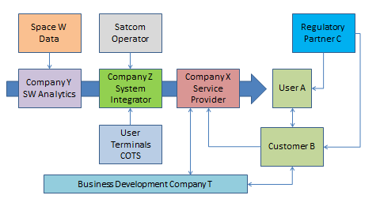
EXAMPLE
Provide a diagram which illustrates the interactions among customers, users, project team (including the service provider) and other key stakeholders (e.g. regulators) in the commercial exploitation phase of the system/service you intend to realise.
Include a discussion of the changes, if any, introduced in the value chain by the proposed new system/service.

The following table provides an overview of the positioning of the Tenderer and its Subcontractor(s) as well as of the involved external key actors together with their position in respect to the feasibility study and the targeted commercial exploitation.

Table 4.1 Partners’ Positioning
Partner | Background and Experience | Role in the feasibility study | Role in  commercial exploitation
……… | ……… | ……… | ………
……… | ……… | ……… | ………
……… | ……… | ……… | ………

System/Service Architecture
A high level block diagram of the system/service showing the key attributes and key building blocks and the main interfaces is provided in the figure below.

Figure 4.2 System/service Architecture
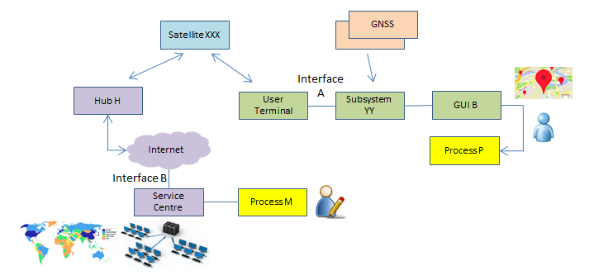
EXAMPLE

Implementation Approach

a) The starting point for our project is:
(e.g., idea, prototype, existing product, existing service, results from other activities, discussions with potential users)

b) The expected goals / outputs at the end of the feasibility study and the way they will contribute to an informed decision for the next steps / further investments:

c) Study Logic:
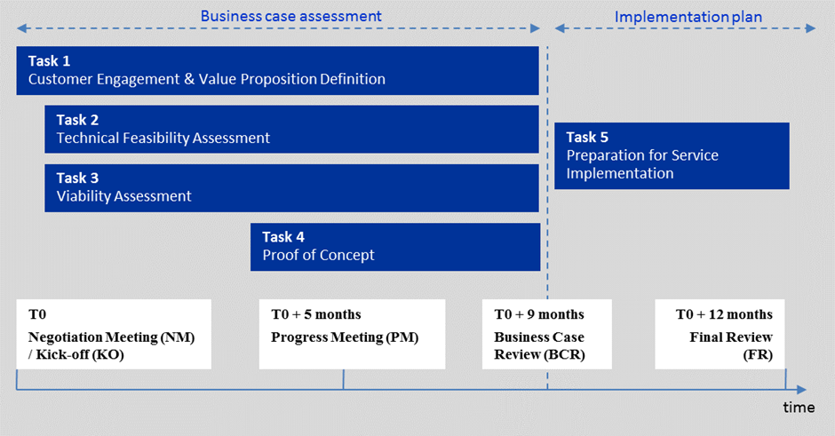
This is the study logic as presented in Figure 2 of the “Management Requirements” . Please, note that this study logic is not compulsory. In case that an alternative study logic and alternative tasks are proposed, this needs to be justified.

d) The key activities proposed to be executed are:

Table 4.2 Key tasks and high level information
WP Identifier  (e.g. WP0000, WP1000, WP2000, …) | WP Title  (e.g. Management, Customer Engagement, Technical Feasibility, …) | Key activities | Responsible Entity | Schedule
……… | ……… | ……… | Prime/Subco | KO-KO+xx m
……… | ……… | ……… | Prime/Subco. | KO-KO+yy m
……… | ……… | ……… | Prime/Subco | KO-KO+zz m

The table provides a high level description of the key activities (e.g. first level Work Packages) to be performed including the time planning information

e) For each of the tasks, the most critical and important issues to be addressed during the study shall be presented.

Table 4.3 Study tasks – major activities & critical / important issues addressed
Study Task | Critical / Important Issues to be addressed
………
………
………
The issues and success factors can cover a variety of aspects, i.e. consortium internal / external such as partnerships, IP, investments, commercial, technological, regulatory, etc.

f) The major technical, operational and business related risks associated with the proposed activity and the associated mitigation plans are:

These risks are summarised in the following table.
(Complete the following table as appropriate)

Table 4.4 Overview of the Major Risks and the proposed Risk Mitigation Actions
Risk Identifier | Description | Likelihood | Severity | Mitigation Actions
……… | ……… | low/medium/high | low/medium/high | ………
……… | ……… | low/medium/high | low/medium/high | ………
……… | ……… | low/medium/high | low/medium/high | ………

g) Proof of Concept (PoC):

g.1) Please describe the Proof(ves) of Concept you propose, including:
- the aim of the PoC: demonstrate the system/service by assessing its specific features/performance, demonstrate integration of space and 5G technologies
- the relevance of the proposed PoC for the development and deployment of the intended service
- which users/customers will be involved and the areas where the PoC (s) will be performed
- the main activities proposed to be performed in the PoC; technical development/integration, testing; deployment and execution of the PoC; tools and indicators to assess the value of the PoC; how the users/customers are involved in the assessment.

g.2 ) 5G for L’ART – 5G assets and related agreement:

- For the Proof of concept in at least one of the proposed L’ART region, the 5G for L’ART users proposed the areas/ sites listed in Annex 1 of the Cover Letter .
- Note that the execution of a proof of concept in at least one relevant locations amongst those proposed in the Cover Letter-Annex 1, is mandatory. Please list here the areas you intend to target in the proof of concept.
- List here the 5G assets you intend to use in the proof of concept and provide evidence of the preliminary- agreement with the considered 5G terrestrial operator(s).
- For each area/sites requested please provide a short description about how it will be used, for how long and for which purpose

g.3) Preliminary authorizations and related documentation required to operate in a certain areas/building(s)/site(s)

Describe here the necessary preliminary authorizations and related documentation required to operate in a certain area(s)/building(s)/site(s) in order to successfully perform the PoC .The specific terms of use/confirmation regarding availability of Roma Capitale, the Municipality of L’Aquila and Abruzzo region, and the Municipality of Torino assets shall be agreed between the Tenderer and the involved municipalities, depending on the above identified needs as refined in the Full Proposal. Following selection of the Outline Proposal the Agency may facilitate the discussion with the interested municipality(ies), as needed involved in the 5G for L’ART opportunity.

Financial, Management, Administrative (FMA)

- The table below provides a high level description of the proposed team, including the internal source of co-funding.
Table 4.5 Main project participants
Company Name | Main figures  (e.g. year of creation, size, turnover, number of employees) | Relevant Experience | Budget (cost) kEUR | Source of co-funding
……… | ……… | ……… | ……… | ………
……… | ……… | ……… | ……… | ………
……… | ……… | ……… | ……… | ………

- The table below provides the breakdown of costing and pricing per contractor.
Table 4.6 Breakdown cost and price for prime and subcontractor(s)
Company/ Organisation | Status (e.g. University, SME) | Country | Cost (kEUR) | Price (kEUR) (requested from ESA) | % Funding from ESA | National Delegation Support
Prime | ……… | ……… | ……… | ……… | ……… | yes/no/under discussion
Subcontractor 1 |  | ……… | ……… | ……… | ……… | yes/no/under discussion
Subcontractor 2 |  | ……… | ……… | ……… | ……… | yes/no/under discussion

- The table below provides an initial overview of the planned manpower distribution over the various Work Packages.
Table 4.7 Planned manpower distribution over work packages
 | WPxxx | WPxxx | WPxxx | WPxxx | WPxxx | WPxxx | Total
 | [%] | [%] | [%] | [%] | [%] | [%] | [%]
Manpower distribution
- The table below provides information and reference of other projects/activities carried out as precursor activities to the proposed study or on related subjects.
Table 4.8 Related projects/activities
Linked Activity Name | Activity description and relevant links with what is proposed in this Outline Proposal | Cost of the Linked Activity  kEUR | Funds received by public sources  kEUR | Timeframe | Related programme / funding agency  EU H2020, FP7, ESA XXX, national programmes
……… | ……… | ……… | ……… | ……… | ………
……… | ……… | ……… | ……… | ……… | ………
……… | ……… | ……… | ……… | ……… | ………
- Other help/support expected from ESA:
(e.g. access to space data, networking, coaching, branding, technical/business advice)

Coordinates of National Delegations can be found under: https://business.esa.int/national-delegations
The source of co-funding needs to be indicated. In case of third party funding, the status of the availability of this funding, and actions to arrive at a formal agreement for this needs to be described.
Please, note that work carried out by universities and research institutes involved as contractors or subcontractors and justifying no further commercial interest in the service or product may be funded up to 100% by the Agency. The decision of the applicable funding level is with the related national delegation. Please, note that work carried out SMEs involved as contractors or subcontractors may be funded up to 80% by the Agency. The decision of the applicable funding level is with the related national delegation.
yes = The National Delegation has been contacted and is in favour of the proposed activity. no = The National Delegation has not yet been contacted. under discussion = The National Delegation has been contacted and discussions are ongoing.

