|  |
| --- |
|  |

Full Proposal Template for ARTES IAP-5G for L'ART Demonstration Projects

# INTRODUCTION

This *Full Proposal Template* is a tool to help the tenderer to prepare a comprehensive Full Proposal responding to the 5G for L’ ART AO for a Demonstration Project.

Please note that, in consideration to the fact that the preparation of the Full Proposal can be started only upon confirmation by ESA that the corresponding Outline Proposal has been accepted, for the purpose of this template it is assumed that several parts of the Full Proposal will be based on information, possibly expanded whenever required, that have been already provided in the Outline Proposal.

Concerning the use of this template, please note the following styles and the related instructions:

* Material presented in this plain style is either suggested content for a Full Proposal, or describes the content to be inserted in the corresponding paragraph, as relevant. This is intended to be an example of a response to the related Agency requirements, which the Tenderer needs to properly complement by activity-specific information. The suggested material may be adopted as is, or modified at the Tenderer’s discretion. It remains the responsibility of the Tenderer to ensure that all of the Agency’s requirements of the present Call for Proposals are properly addressed.
* This style is used to identify information that must be modified and/or completed by the Tenderer for the proposed activity. This supplementary information shall presented in plain typeface (i.e. not red) in the final version of the Full Proposal.
* This style is used for explanatory notes and guidance to help you to develop the Full Proposal content (e.g. to indicate a selection between mutually-exclusive options). This information should be removed from the final version of the Full Proposal.
* Parts with the paragraph title highlighted in green in this template shall correspond to the relevant sections provided in the Outline Proposal to be repeated “as is” in the full proposal for sake of completeness

Use of this Full Proposal Template is mandatory. The Tenderer shall not change the structure of this Full Proposal Template (i.e. the table of contents must remain unchanged).

Please note that the Full Proposal is the only document that will be considered by the ESA Tender Evaluation Board, which will not have access to the Outline Proposal. Therefore, the Full Proposal shall be considered as a full self-contained document, and the contributions coming from the Outline Proposal shall be explicitly appearing in the Full Proposal.

**The length of the completed Full Proposal without Annexes shall not exceed 75 pages (without changing font size or page margins).**

Some Participating State Delegations may require to access the full proposal to grant their Authorisation of Funding (AoF). Please timely coordinate with the relevant delegation(s) about the applicable process.

Please use this page as the cover page of the Full Proposal and remove the previous three pages (Template Title page and Introduction)

Project Name

Full Proposal for IAP-5G for L’ ART Demonstration Project

Date: ……

Reference: ……

ESA Template Ref 1.0 issued 05/11/2019

INTRODUCTION 1

A. COVER LETTER 3

B. PROJECT SUMMARY AND RATIONALE 3

B.1 Background Information 3

B.2 Service Description and Selling Point(s) 3

B.3 5G and Space Asset(s) and Rationale 3

C. Business Plan 4

C.1 Customer Segments 4

C.2 Value Propositions 4

C.3 Channels 4

C.4 Customer Relationships 5

C.5 Revenue Streams 5

C.6 Key Resources and Dependencies 5

C.7 Key Activities 5

C.8 Key Partners 6

C.9 Cost Structure 7

C.10 Competitive Landscape 8

C.11 Market Analysis 8

C.12 Exploitation Plan 9

C.13 Financial Indicators 10

D. TECHNICAL PROPOSAL 12

D.1 User Requirements 12

D.2 System / Service Architecture 12

D.3 Implementation Approach 13

D.4 Pilot-Demonstration Service 14

D.5 Technical and Non-Technical Risks 16

D.6 Letters of Participation by Users and Other Stakeholders 16

D.7 Annex D.1 17

D.8 Annex D.2 18

E. Management and Administrative Proposal 19

E.1 Background experience 19

E.2 Organisation and management 19

E.3 Facilities 19

E.4 Key personnel 19

E.5 Travel and subsistence plan 20

E.6 Monthly Progress Reports 20

E.7 Minutes of Meetings 20

E.8 Project Web Page 21

E.9 Annex F - CV of Key Personnel 22

F. IMPLEMENTATION Proposal 23

F.1 List of Deliverables 23

F.2 Work Breakdown Structure (WBS) 26

F.3 Work Package Descriptions (WPDs) 27

F.4 Planning 29

G. FINANCIAL Proposal 30

G.1 Cost and Price Summary 30

G.2 PSS Forms 30

G.3 ANNEX PSS Forms 33

G.4 Source of the Entity Contribution 34

G.5 Statement of Profit 34

G.6 Currency and Conversion Rates 34

G.7 Type of Price 35

G.8 Quotations Free of Taxes and Customs Duties 35

G.9 Milestone Payment Plan 35

H. CONTRACTUAL Proposal 38

H.1 Compliance with the Contract Conditions 38

H.2 Insurance Waiver 38

H.3 Statement Relating to Export Import Licences / Authorisations and Related Documentation 38

I. List of ACronyms 40

# COVER LETTER

THE COVER LETTER IS PROVIDED AS A SEPARATE DOCUMENT

# PROJECT SUMMARY AND RATIONALE

## Background Information

Project Name: ……

Prime and contact points: ……

Prime information: ……

Rest of the consortium: ……

## Service Description and Selling Point(s)

Description of the product / service you intend to offer

Innovation / key selling point(s) with respect to what is available in the market

How does the proposed final product / service fit within your current business activities and your mid-/long-term strategy?

What is the relevance to the thematic call objectives? Which use case do you propose to address? How?

## 5G and Space Asset(s) and Rationale

5G and Space technology / space asset(s) intended to be used, and rationale

Rationale for integration of the 5G and space asset(s) / space technology

Purpose, areas and assets proposed for the pilot

# Business Plan

## Customer Segments

The key customers/customer segments targeted by our product / service are: ……

The pains (e.g. problems) and gains (e.g. benefits) are: ……

The potential customers already identified are: ……

The following table provides a summary overview of the customers and associated high level characterisation in relation to the target product(s).

Table C.1 Key Customers/Customer Segments and their Needs

|  |  |  |
| --- | --- | --- |
| **Customer/Customer Segment** | **Customer Problems/Needs** | **Representativeness for the Targeted Market** |
| ……… | ……… | ……… |
| ……… | ……… | ……… |
| ……… | ……… | ……… |

## Value Propositions

The table below identifies the specific characteristics of our product / service that will address the previously-identified customer problems/needs. (e.g. performance, cost, new features) and define its value proposition i.e.: value that the product or service offers to its customers.

Table C.2 Key Product Characteristics

|  |  |  |  |
| --- | --- | --- | --- |
| **Customer Segment** | **Problem/Need** | **Product Characteristics Addressing this Problem/Need** | **Value proposition** |
| Customer Segment 1 | …… | …… | …… |
| Customer Segment 2 | …… | …… | …… |
| …… | …… | …… | …… |

Explain the relevance of your value proposition to address user needs in the selected use case(s) and outline the expected benefits for the user communities.

## Channels

In the commercial exploitation stage, our product / service will be sold to the customers via these channels: ……

## Customer Relationships

Our relationships with the key customers already exist / must be created / have to be improved.

## Revenue Streams

In the commercial exploitation stage, our product / service will be sold to our customers as described in the tables below, based on the market analysis reported in Section 2.11.

To justify the assumptions about the price to which the product will be sold, some high level considerations about the Cost Benefit Analysis (CBA) for the customers should be provided. Such considerations should give the rationale that the acquisition of the product for its cost is worthwhile for the customers.

Table C.3 Product Pricing

|  |
| --- |
| Customer Segment 1(*)  Customer Segment 2  Customer Segment 3  Churn Rate  Product  unit price  Product  installation  charge per  unit  Service fee  per product  per year  Customer Segments  *(*) Please use the definition used in Table C.2* |

## Key Resources and Dependencies

To realise our product / service and deliver the value propositions we need the critical resources and dependencies that are defined in the following table, as applicable.

Table C.4 Key Resources and Dependencies

|  |  |  |
| --- | --- | --- |
| **Required Resource** | **In Place** | **Potential Issues** |
| ……… | yes/no | ……… |
| ……… | yes/no | ……… |
| ……… | yes/no | ……… |

## Key Activities

To realise our product / service and deliver the value propositions we need to perform the key activities identified in the table.

Table C.5 Overview of Key Activities

|  |  |  |
| --- | --- | --- |
| **Key Activity** | **Description** | **When are going to be performed (during or after the project)** |
| ……… | ……… | ……… |
| ……… | ……… | ……… |
| ……… | ……… | ……… |

## Key Partners

The value chain involves the key partners defined in the table below.

Table C.6 Key Partners

|  |  |  |  |
| --- | --- | --- | --- |
| **Partner Name** (company name, country, web link) | **Background / Experience** | **Involvement in the Project and/or in commercial exploitation** (e.g. none, subcontractor, supplier, pilot user, customer, integrator) | **Type of Agreement** (e.g. NDA, partnership agreement, contract) |
| ……… | ……… | ……… | ……… |
| ……… | ……… | ……… | ……… |
| ……… | ……… | ……… | ……… |

Please, take into account partners during the project stage may not be the same as during exploitation (e.g. HW factory producing the designed product may not have a role during the project, but it will be necessary during exploitation). Please explain the status of those relationships (existing, in progress, to be established…) complementary to the info of the table above.

The following diagram describes the project partners and their role in the project and in the commercial exploitation stage of the product / service.

Figure C.7 Project Team Composition and Roles

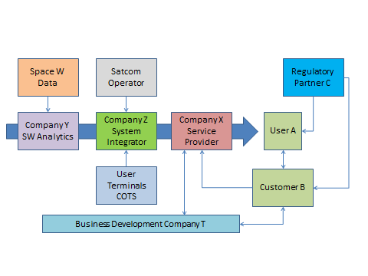

## Cost Structure

The key elements of cost for realising the value proposition are presented in the following tables.

|  |
| --- |
| Table C.8 Cost of Sales  Jan-18  0  1  2  3  4  5  6  7  8  Commercial Exploitation Phase  Simplified CoS for product  unit  Cost Element N.1  Estimated Cost of Sales  Cost Element N.2  Cost Element N.3  Cost Element N.4 |

|  |
| --- |
| Table C.9 Operational Expenditures |

|  |
| --- |
| Table C.10 Capital Expenditures |

The following assumptions have been used to derive the figures provided in the tables above: ……

## Competitive Landscape

Our product / service is addressing the market of …… (e.g. provide few examples), which has the following characteristics: …. (e.g. geographical reach, trends, sales model).

Our key competitors and the nature of the competition are identified in the table below.

Table C.11 Summary of the Competition

|  |  |  |
| --- | --- | --- |
| **Competitor** | **Characteristics** | **References** |
| ……… | ……… | ……… |
| ……… | ……… | ……… |
| ……… | ……… | ……… |

Our key competitive differentiations are summarised in the following table.

Table C.12 SWOT Analysis

|  |  |
| --- | --- |
| **STRENGTHS**  - List of strengths | **WEAKNESSES**  - List of weaknesses |
| **OPPORTUNITIES** - List of opportunities | **THREATS** - List of threats |

## Market Analysis

The market, its size and the geographical reach are: ……

The position of our product / service in the market is summarised in the matrix below.

Table C.13 Market positioning

|  |  |  |  |  |
| --- | --- | --- | --- | --- |
| MARKETS | New (MN) | ………. | ………. | ………. |
| Adjacent (MA) | ………. | ………. | ………. |
| Existing (ME) | ………. | ………. | ………. |
|  | | Existing (PE) | Incremental (PI) | New (PN) |
| PRODUCT / SERVICE | | |

Our projection in terms of the market we aim to capture in the short term for each of the identified customer segments is shown in the following table.

Table C.14 Served Obtainable Market 

Present the underlying assumptions that led to the projected sales volumes over time.

The assumptions behind the above sales projection are ……

## Exploitation Plan

Time of commercial entry into the market and way forward to bring the activity results to commercial product / service: ….

Expected economic, social or environmental benefits inside and outside the consortium, and associated timescale: …..

## Financial Indicators

A profit and loss and cash flow statement is provided in the table below.

Table C.15 Profit & Loss and Cash Flow Statement

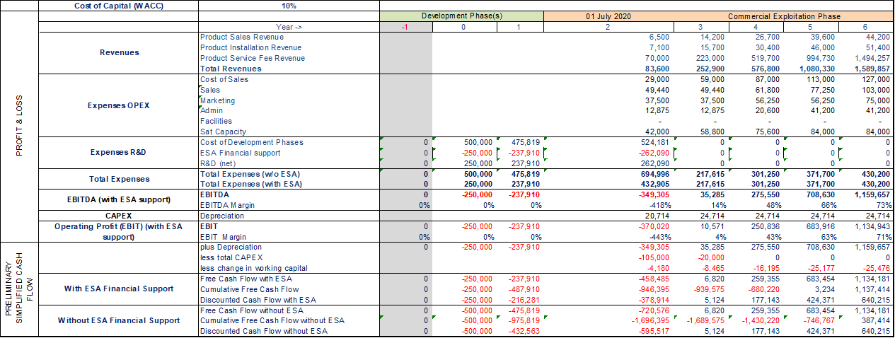

(The above is just an example. The above table can be found in the spreadsheet file) (The above is just an example. The above table can be found in the spreadsheet file)

Table C.16 Financial Indicators with and without ESA Support

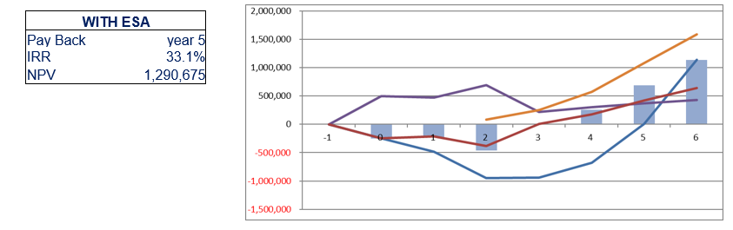

(The above is just an example. The above table can be found in the spreadsheet file)

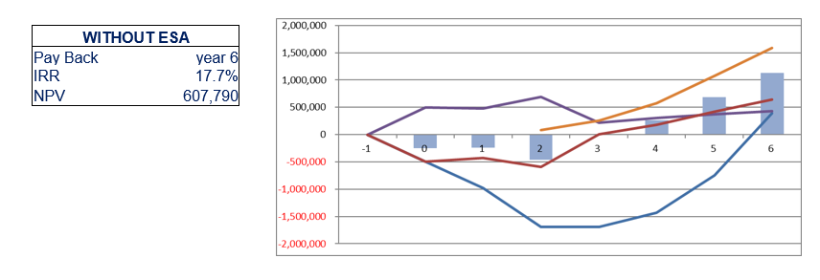

# TECHNICAL PROPOSAL

## User Requirements

The following table provides a first iteration of the user requirements.

Table D.1 User Requirements

| **Req. ID** | **User Requirement Name** | **Description and Rationale** | **Related customer segments** | **Verification method and Pass/Fail criteria** |
| --- | --- | --- | --- | --- |
| UR-A_001 | ……. | ……. | ……. | ……. |
| ……. | ……. | ……. | ……. | ……. |
| ……. | ……. | ……. | ……. | ……. |

*Verification method shall be considered and (where relevant) documented while writing the requirements (e.g. some of the possible verification methods being Review of Design (RoD), Test (T), Simulation(S) etc.). Hint: words such as “adequate, easy, high speed, maximise, minimise, quickly, robust, sufficient, use’-friendly” are likely to indicate unverifiable requirements and should not be used.*

The intended approach to identify the user requirements during the project execution will be based on …. (e.g. waterfall, agile). The planned level of involvement of the pilot user in this process is ….

## System / Service Architecture

A high level block diagram of the system / service showing the key attributes and key building blocks and the main interfaces is provided in Figure 3.3.

Table D.2 System/service Architecture

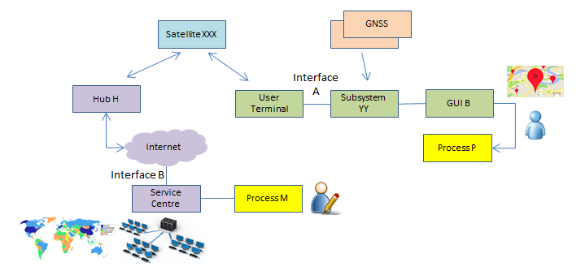

EXAMPLE

With reference to the figure above, the pilot system to be deployed in the proposed activity will consist of the following elements:

* Remote terminals…/ number of remote sites
* Service centre…
* Etc.

If more than one pilot demonstrator is proposed, identify which part of the pilot system are used in each proposed pilot demonstrator

## Implementation Approach

The expected goals / outputs at the end of the activity and the way they will contribute to the final product / service are: ……

The starting point for our project is: ……

The key activities proposed to execute are:

The elements to be developed in the proposed activities are ……

Our proposed development approach is the following: …… (describe the source of the key building blocks, such as existing elements and/or all items to be developed). This will result in the following hardware / software models to be built, verified and delivered: prove of concept, fully operational prototype, commercial product/service.  
The overall product development approach is here outlined: …….

The Tenderer is invited to consider Model-based systems engineering (MBSE) approach, namely for large and complex projects, or when MBSE tools are already used internally by the Tenderer.

## Pilot-Demonstration Service

The pilot-demonstration service activities will be based on the following undertakings: objectives, users/customers involvement, envisaged utilisation of the system, e.g. 2 hours of use every day, duration of the pilot-demonstration stage e.g. 8 months, etc.

The following 5G and space asset(s) will be used in the pilot-demonstration: ….

The expected preparation activities of the pilot-demonstration will include: specify as needed (e.g. deployment, integration within the user environment, acceptance, logistics, training).

The users, customers, stakeholders participating in the pilot-demonstration, the related level of involvement and a short description of the activities to be performed by them is summarised in the table below.

Table D.3 Involvement of Users, Customers and Other Stakeholders in the Pilot-Demonstration

|  |  |  |  |
| --- | --- | --- | --- |
| **Name** | **Role in the Pilot-Demonstration** | **Activities** | **Agreement and associated status (in place, to be secured in Full Proposal, etc.** |
| ……… | ……… | ……… | In place / in Full Proposal… |
| ……… | ……… | ……… | In place / in Full Proposal… |
| ……… | ……… | ……… | In place / in Full Proposal… |

*Please note that following review of the Outline Proposal the Agency may facilitate the discussion with the interested municipality(ies), as needed, involved in the 5G for L’ART opportunity.*

The success criteria / goals to be achieved during the pilot-demonstration to gain customer commitment are: …..

Preliminary considerations for evaluating system and service performance during the pilot-demonstration are here summarised:

* Define the specific objectives of the pilot (list of high level objectives technical, business, etc.)
* Identify the Key Performance Indicators (KPIs) to assess whether the objectives have been met
* Map each objective to one or more KPI
* Identify an expected value for each of the KPI
* Describe tools and procedures to collect the value of each KPI…..

Our approach to promote the commercial uptake of the product / service is: ….. (e.g. incentives for project pilot-demonstration users to subscribe to the operational service).

During the pilot, the operations will be reported on weekly basis in line with the template of the Pilot Operations Summary Report (POSR).

1. *The success criteria / goals shall be presented in terms of Key Performance Indicators (KPI’s) that quantitatively measurable and are relevant for inferring commercial uptake of the service after the end of the project. Therefore, the KPI’s must be relevant to the pilot users and potential customers and their interest in adopting the service. KPI’s must be related to the value propositions.*
2. *Please also describe the Pilot you propose, including:*

* *the aim of the Pilot: demonstrate the system/service by assessing its specific features/performance, demonstrate integration of space and 5G technologies*
* *which users/customers you propose to involve and the areas where the Pilot (s) is planned to be performed*
* *the main activities proposed to be performed in the pilot*

1. *Please note that the execution of the pilot in at least one relevant areas/building/monuments/sites amongst those proposed in the Cover Letter-Annex 1, is mandatory.*

1. *5G for L’ART assets required for the Pilot: In order to perform at least one pilot in at least one of the proposed L’ART region, the 5G for L’ART partners proposed the areas/ sites listed in Annex 1 of the Cover Letter. Please provide evidence of the agreement*
2. *Please describe the areas you intend to use to perform the pilot.*
3. *Please also list here the 5G assets you intend to use during the pilot and provide evidence of the preliminary- agreement with the considered 5G terrestrial operator(s).*
4. *Please provide here evidence of the necessary authorizations and related documentation required to operate in a certain area(s)/building(s)/site(s) in order to successfully perform the pilot.*
5. *The specific terms of use/confirmation regarding availability of Roma Capitale, the Municipality of L’Aquila and Abruzzo region, and the Municipality of Torino assets shall be agreed between the Tenderer and the involved municipalities, depending on the above identified needs as refined in the Full Proposal.*

## Technical and Non-Technical Risks

The major technical, operational and business related risks associated with the proposed activity and the associated mitigation plans are: ……

These risks are summarised in the following table.

(Complete the following table as appropriate)

Table D.4 Overview of the Major Risks and the proposed Risk Mitigation Actions

|  |  |  |  |  |
| --- | --- | --- | --- | --- |
| **Risk Identifier** | **Description** | **Likelihood** | **Severity** | **Mitigation Actions** |
| ……… | ……… | low/medium/high | low/medium/high | ……… |
| ……… | ……… | low/medium/high | low/medium/high | ……… |
| ……… | ……… | low/medium/high | low/medium/high | ……… |

## Letters of Participation by Users and Other Stakeholders

The users, customers and other stakeholders involved in the proposed project have issued statements confirming their participation in the pilot application and indicating their interest in the commercial stage of the activity. These statements are attached as Annex D.X to this Full Proposal.

OPTION: The following customers have stated their willingness to subscribe to the service upon successful conclusion of the Demonstration Project: ……. Formal statements are provided via the Letter(s) of Intents attached as Annex D.Y.

## Annex D.1

**Statement from users, customers and other external partner organisation(s) and evidence of the agreement with the 5G operator(s)**

*[Please, enclose a ‘Letter of Interest / Commitment’ for each participant (customer, user, other external partner organisation) not appearing explicitly as subcontractor, containing information on their motivation for their participation (in their own words) as well as information on their contributions to the various study tasks.*

*Contributions to the demo project may include:*

* + *identification of current operational processes and their issues,*
  + *support to definition of user scenarios/processes,*
  + *support to definition of user requirements,*
  + *identification of expected benefits and financial constraints,*
  + *support with validation of the Pilot,*
  + *support to promotion of the targeted services*
  + *evidence of the agreement with the 5G operator(s)]*

## Annex D.2

**Statement from potential customers**

*Statements from potential customers confirming their willingness to subscribe to the service upon successful conclusion of the Demonstration Project.*

# Management and Administrative Proposal

## Background experience

*Presentation of the Tenderer / Subcontractor(s) and their organisational structure (e.g. key company details, turnover, ownership…).*

*Background description and relevant experience of the tenderer, subcontractors, users, partners (if applicable).*

*Description of direct and indirect results of any previous ESA ARTES Applications contracts (for instance via the relevant Summary & Achievements document, if available) involving any company of the bidding team. The direct results shall show the revenues and profits, in Euro, obtained in the 3 years following the end of the ESA projects. Presentation of the service provider and its role in the consortium team, if included.*

*Indicate the “Vision” of the tenderer and, where relevant, of its subcontractor(s). How does it fit into the company(ies) strategy / roadmap.*

## Organisation and management

*Presentation of the project team and of the structure of the project organisation (including users / stakeholders), and where it is proposed to subcontract part of the work, the structure of the industrial group. Include identification of the nominated Project Manager and Contractual Manager, both should usually belong to the organisation of the Prime Contractor.*

*Lines of communication and reporting, and means for settling disagreements.*

*Management plans, policies and procedures: management control organisation, procedures that will be used to exercise control over the project and the proposed subcontracting control (if any) and coordination with the user community.*

## Facilities

*Description of all facilities to be used including those facilities which are still to be developed / built and / or purchased, with a statement on whether the costs of developing / building / purchasing the facility are to be directly or indirectly charged to the Contract. Modifications to existing facilities are also to be described. For this purpose, facilities may include, as applicable, hardware, computer software, manufacturing equipment, test equipment, production and integration lines, service centres and infrastructures hosting the user communities.*

*Description of means of access to space assets and space based services as relevant, information resources, such as libraries, databases… the company has, if these are required for the work proposed.*

## Key personnel

Key personnel are identified as persons who, because of their individual qualifications and positions are proposed for the work and indicated as such in the tenderer's Organisation Breakdown Structure. As a minimum, each person assigned as Work Package Manager shall be nominated as Key Personnel. Key representative of the users shall also be presented.

The following table provides an overview of the allocation of the Key Personnel to the proposed activities.

Table E.1 Key Personnel

|  |  |  |  |  |  |
| --- | --- | --- | --- | --- | --- |
| **Name** | **Role in the Project** | **Company** | **Manager of WP** | **WP(s) allocation in h** | **Average allocation of time for the duration of the project** |
| ……… | Project Manager | ……… | WP1100 | WP1100 [120h], WP2300 [230h] | 80 % |
| ……… | Business Developer | ……… | WP1200 | ……… | ………% |
| ……… | ……… | ……… |  | ……… | ………% |

The CVs for all key personnel are provided in Annex F. Each CV provides:

- a summary of the work experience of the person concerned;

- a brief description of their present job and responsibilities;

- their specific qualifications and experience of direct relevance to their role in the project.

## Travel and subsistence plan

Travel and subsistence plan is provided in the Exhibit B of the PSS-A2 forms.

The first project meeting (Negotiation or Kick Off Meeting) and the last project meeting (Final Review) shall be done at ESTEC or ECSAT and shall be included in the travel and subsistence plan.

## Monthly Progress Reports

A concise monthly progress report will be provided to the Agency within the first five working days of each month. The template available in the [Business Applications web site](https://business.esa.int/documents), section “documents” will be used.

## Minutes of Meetings

Each review meeting will be organised using the Draft Agenda available in the [Business Applications web site](https://business.esa.int/documents). Formal written minutes of meetings attended by the Agency will be agreed and will be signed and made available to the Agency at the end of the meeting.

The minutes will, as a minimum, identify all agreements made and actions accepted during the meeting.

The following identification scheme will be used to define the Action Items:

Action X.Y

where X is the identifier of the meeting (0: Negotiation Meeting, 1: First Review Meeting, 2: Second Review Meeting, etc.), and Y is the Action number starting from 1 at each new meeting.

All Actions Items will be recorded in the Distributed Project Collaboration Tool made available by ESA, and the associated status will be kept up-to-date by the Project Manager.

## Project Web Page

A first version of the project web page will be produced as part of the deliverable documentation package for the BDR using the latest template specified by the Agency.

The project web page will be updated periodically during the development so that the project and its current status are properly portrayed.

For each milestone review as a minimum, the current status paragraph of the project web page and, if appropriate, other web page content, will be updated and communicated to the Agency.

The final version of the project web page will be provided to the Agency together with the final version of the Final Report. It will include a paragraph summarising the most significant achievements of the project.

## Annex F - CV of Key Personnel

**Curricula Vitae of the Key Personnel**

Provide completed CVs for all members of the key personnel using the following template, or equivalent. Competence in technical, business development, market expert or insider, commercial and sales shall be explicitly presented.

|  |  |
| --- | --- |
| **Name** | |
| Specific Qualifications and Experience Relevant to the Project Role: | … |
| Entity: | … |
| Present Position and Responsibilities in the Entity: | … |
| Education: |  |
| Year(s) | Educational details |
| Year(s) | Educational details |
| Work Experience: |  |
| Year(s) | Entity, Project, Position, Responsibilities, Achievements |
| Year(s) | … |
| Year(s) | … |

# IMPLEMENTATION Proposal

## List of Deliverables

The documents that will be delivered during the project are summarised in the table below.

Table F.1 Deliverable documents

| **Name** | **Deliverable** | **Initial Submission** | **Updating** | **Final Submission** |
| --- | --- | --- | --- | --- |
| PBC | Project Bar Chart | with the proposal | as part of the MPR and at reviews |  |
| MPR | Monthly Progress Report | TO + 1 month | every month, within first five working days |  |
| MOM | Minutes of Meetings | NM | every meeting | FR |
| RD | Requirements Document | with the proposal | BDR | FR |
| SSA | System and Service Architecture | with the proposal | CDR | FR |
| PilUP | Pilot-Demonstration Utilisation Plan | with the proposal | FAT, SAT | FR |
| DM | Digital Media (as part of the FDP) | FR |  |  |
| SVD | System Verification Document | CDR | FAT | SAT |
| BP | Business Plan | with the proposal | BDR, other milestones as relevant | FR |
| POSR | Pilot-Demonstration Operations Summary Report | SAT | Once every two weeks basis, unless otherwise agreed with ESA | FR |
| PWP | Project Web Page | BDR | current Status to be updated as part of the Monthly Progress Report | FR |
| FREP | Final Report | FR |  |  |
| FDP | Final Data Package | FR |  |  |
| S&A | Summary and Achievements | FR |  |  |

Each deliverable document will include a title page reporting the project name, the contract number, the title of the document, a reference identifier, the author(s) and related organisation(s), the date of issue and the revision number.

All deliverable documents will include a record of the document history, indicating in short for each document revision the corresponding date and the reason(s) for the revision. The relevant copyright marking in line with the contract provisions shall be clearly identified.

All documentation will be delivered in electronic form, in MS Word or equivalent, with all pictures and tables embedded in the document. The documentation will be able to be printed and will allow the insertion of comments and track changes. Intermediate versions of the documents, before its final official release, shall be delivered in Track Changes.

All deliverable documents will be delivered using the Agency’s web-based project planning and collaboration tool. Documents will be delivered at least five working days prior to the associated review.

The following table describe the list of Hardware and Software and associated Documentation that will be delivered to ESA as part of the proposed project.

Table F.2 Deliverable Items

Entries in the table are just examples to be amended as relevant

|  |  |  |  |  |  |
| --- | --- | --- | --- | --- | --- |
| **Type** | **ID** | **Item description** | **Number of Items** | **Deliverable Point** | **Notes** |
| Portable  Demonstrator (when practical) | PD | ……… |  | ESA | Self-contained setup to support visual presentation of the product / service to non-expert people |
| Hardware | HW.01 | Satcom user terminal | 6 | User sites A, B, … | 80 cm dish… |
| HW.02 | Handheld tablet | 8 | User sites c, d, … | Model…. |
| HW.03 | Server | 1 | Service centre | Model .... |
| HW.04 | Portable Demonstrator | 1 | To ESA at the FR | ……… |
| ……… | ……… | ……… |  | ……… |
| Software(*) | SW.01 | M&C Fleet | 1 | Service centre | ……… |
| SW.02 | Mobile App | 8 |  | Embedded in HW.02 |
| ……… | ……… | ……… |  | ……… |
| Manuals | DOC.01 | User manual | 8 | Together with HW.02 | ……… |
| DOC.02 | Service Centre Installation | 1 | Together with HW.03 | ……… |
| ……… | ……… | ……… |  | ……… |

Please note that the Hardware (listed above) shall only include the items fully costed to the project.

Hardware procured and charged under an amortisation scheme (e.g. two years use of a server with a five years lifetime) are not project deliverables, but shall be itemised in the Exhibit A of the PSS-A2 forms.

(*) Delivery of the Software will be performed by storing the SW modules and versions developed under the project in a secure software repository (on-site or in the cloud). Up to two years after the contract closure date, ESA will be provided access to the repository by contacting the Project Manager.

## Work Breakdown Structure (WBS)

The figure below presents the work breakdown structure, covering the entire scope of the proposed work.

Replace the following diagram with an equivalent showing the proposed work breakdown structure; provide at least two levels. Entries in the table are just examples to be amended as relevant

Figure F.3 Work Breakdown Structure

Project Name

WP1000  
Management

(Prime)

WP2000  
Req.s and Design (……)

WP3000  
Dev. and Integ.

(……)

WP4000  
Pilot Service

(……)

WP5000  
Business Development

(……)

WP1100  
Pr. Management

(Prime)

WP1200  
User management

(…….)

WP1200  
……..

(…….)

WP2100  
User/ Sys. Req.

(…….)

WP2200  
Analysis   
(…….)

WP2300  
……..

(…….)

WP3100  
SW Development

(…….)

WP3200  
Verification

(…….)

WP3300  
……..

(…….)

WP4100  
Inst. and Commiss.

(…….)

WP4200  
Pilot Service

(…….)

WP4300  
……..

(…….)

WP5100  
Business Plan

(…….)

WP5200  
Service Exploitation

(…….)

WP5300  
……..

(…….)

Level 1 WPs

Level 2 WPs

## Work Package Descriptions (WPDs)

A work package description form (PSS-A20) is presented herewith below for each of the work packages at the lowest level of the work breakdown structure.

In general, in case the WBS is based on two levels WPs, the WPDs will refer only to the second level WPs, and the first WPs will not be associated to any WPD.

The work package descriptions comply with the following requirements:

* There is a single work package manager for each work package, who is a member of the key personnel.
* Work packages start and end on milestone events and do not span the entire duration of the activity (except for the project management work package and the closely associated management functions).
* Inputs from other work packages are clearly identified.
* The work to be performed is described in sufficient detail for the Agency to be able to judge the value for money, including scope of work and man-hours.
* Each task is traceable with a corresponding work package output.
* Each work package has at least one traceable work package output (hardware, software and/or documentation item, deliverable to the Agency).
* All deliverable hardware, software and documentation items are traceable to the identified work packages.

Provide completed work package descriptions for each work package identified in the work breakdown structure. Entries in the table are just examples to be amended as relevant

|  |  |
| --- | --- |
| PROJECT: Project Name PHASE: N.A. | WP: 1100 |
| WP Title: Pr. Management  Company: Prime  WP Manager: Project Manager Name  Start Event: KOM Planned Date: To  End Event: FR Planned Date: To+24m | Sheet 1 of 1  Issue Ref …  Issue Date … |
| Inputs:  - Project Proposal  - IAP Management Requirements for IAP Demo Projects, v.X.Y  …  Tasks:  - Coordinate activities with Subcontractors  - Liaise with ESA  - Quality Control of Deliverables  …  Outputs:  - Minutes of Review Meetings  - Monthly Progress Report  - Project Web Page  - Final Report  - Summary and Achievements  … | |

## Planning

*The project schedule shows the start date, the end date and the duration of each work package and the timing of the contractual reviews and other review meetings. The planning takes into account the need of the Agency to review and / or approve intermediate deliverables and allows at least 10 working days for the Agency to do this.*

The GANNT chart below is just a simple explicative example

F**igure F.4 GANTT Chart**

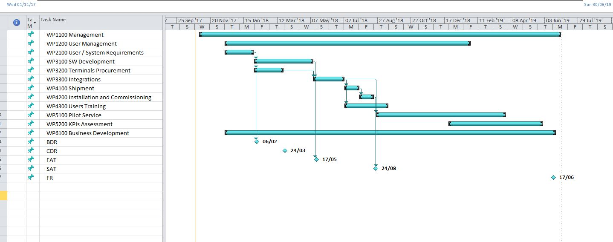

# FINANCIAL Proposal

## Cost and Price Summary

The cost and price for the project is as defined in the following table.

F**igure G.1 Cost and Price Summary**

|  |  |  |  |  |
| --- | --- | --- | --- | --- |
| **Entity** | **Country**  **(ISO Code)** | **Role** | **Cost in Euro** | **Price in Euro** |
| Tenderer | … | Prime | €…,… | €…,… |
| Subcontractor 1 | … | Subcontractor | €…,… | €…,… |
| Subcontractor 2 | … | Subcontractor | €…,… | €…,… |
| … | … | … | … | … |
|  | | **Total:** | **€…,…** | **€…,…** (…% of total cost) |

*[When mentioning the Price of the activity, please, refer to the amount to be funded by ESA. The total cost of the activity is the complete activity cost composed of the ESA funding (firm fixed price to ESA) and the company’s contribution.*

F**igure G.2 External Service Providers**

|  |  |  |  |  |  |
| --- | --- | --- | --- | --- | --- |
| **Service Provider** | **Country**  **(ISO Code)** | **Charged to Entity** | **Nature of the service** | **Cost Breakdown in Euro** | **Cost in Euro** |
| Service Provider 1 | … | Prime | … | Number of units, €/unit €…,… | €…,… |
| Service Provider 2 | … | Subcontractor 1 | … | €…,… | €…,… |
| Service Provider 3 | … | Subcontractor 1 | … | €…,… | €…,… |
| … | … | … | … | … | … |

*Costs related to marketing activities (PR material, participation in conferences, exhibitions, etc.) are eligible up to 3% of the total cost.]*

## PSS Forms

The PSS forms are attached in Annex PSS Forms for the Tenderer and for each of the proposed Subcontractor(s), showing, per entity, the total cost of the proposed work (i.e. including the entity’s share):

PSS-A1;

PSS-A2 (including Exhibits A and B, where applicable);

PSS A8 (reflecting the lowest level of the WPDs);

PSS A15-1.

The PSS forms in Excel format can be downloaded from EMITS, Reference Documentation > Administrative Documents > PSS Forms. The PSS Forms shall be signed (in particular the PSS-A1 and A2) by an authorised representative of the relevant contractors (Prime and each subcontractor, as relevant). Insert in this template the scanned PSS-A1 and PSS-A2 forms signed.

Notes for the compilation of the PSS Forms:

1. PSS-A1 shall include the validity period covering the full duration of the project
2. PSS-A2 shall include Exhibit A (other direct cost elements) and Exhibit B (travel plan and cost detail)
3. In order to facilitate the participation of the key users to major projects reviews (typically, BDR and FR), travel costs incurred by users can also be included in the project costs
4. Contributions from users and/or other stakeholder(s) can be recognised as allowable cost of the project. These contributions must be restricted exclusively to the demonstration project supported by ESA. They must be recorded in the PSS-A2 form(s) of the Tenderer (or its Subcontractor, where applicable) under “OTHER COST ELEMENTS”, and be further detailed in a letter of support signed by the user or stakeholder and in the Exhibit A of the relevant PSS A2 form, indicating the number of hours and hourly rates, facilities (if any) and the WP number(s) to which the users/stakeholder contributes
5. All hardware, software and or services procured for the project shall be listed in the PSS-A2 under the voice 3.6-External Major Products (for hardware and software) and 3.7-External Services (for services). These costs shall be broken down detailing each single cost element in the Exhibit A of the PSS-A2, indicating the number of units and the total costs. The cost elements detailed in exhibit A shall be self-explanatory
6. Hardware and software whose use is not limited to the demonstration project shall be amortised over its lifetime and only the period (months) in which they will be used for the project shall be listed as eligible project costs
7. All hardware, software whose cumulative value exceed 10.000 Euro shall be provided with details of the procurement source (Name of the company and country)
8. All external services whose cumulative value exceed 10.000 Euro shall be provided with details of the procurement source (Name of the company, country, number of man hours quoted and rate/hour, detailing any major additional cost item quoted in the service)
9. If the country of procurement of hardware, software and/or external services is different from the one of the company that is procuring them, an approval of the National Delegation of the country may be required. It is duty of the prime contractor to inform the National Delegation of the intention to procure the item outside the country of origin and seeking for its approval
10. PSS-A8 shall be compiled taking into account the WPs for which a WPD does exist. Typically, if the WBS is structured with a two levels WPs, the PSS-A8 shall refer to the WPs of Level 2, e.g. WP1100, WP1200, .., WP2100, WP2200, …
11. PSS_A15 shall show the full cost profile of the company disbursement, and the payments received  
    from ESA (e.g. 50% of the project costs) reflected in the Milestone Payment Plan; the advance payment shall not be recorded

## ANNEX PSS Forms

PSS-A1;

PSS-A2 (including Exhibits A and B);

PSS A8;

PSS A15.1.

## Source of the Entity Contribution

The source of the entity contribution (including from any private third party) to the overall development costs is as follows:

Tenderer name (tenderer): ….

Candidate Subcontractor 1 name (subcontractor): …….

Candidate Subcontractor …. name (subcontractor): …….

It is confirmed that, in all cases, the entity contribution excludes:

overheads included in rates charged to the Agency for the contract, or any other contract with the Agency, or sub-contract awarded under an Agency contract

Examples of possible sources of co-funding are: existing funds in bank account coming from sales/profit, already approved/prospective bank loan, investment from external source e.g. private investment funds, other contributions. EU and/or national funds coming from e.g. R&D programmes are not allowed.

The purpose of this information is to provide evidence on the capabilities of the involved company(ies) to pay their share of the cost of the proposed activity elements (procurements, facilities, manpower) and, as such, can serve the obligations of the activity.

The bidder(s) is(are) kindly invited to provide evidence of the co-funding in the form of a letter(s) of commitment from investor(s), bank guarantee(s), loan(s) or own resources (e.g. cash and other liquidity).

## Statement of Profit

This financial offer is exclusive of profit.

## Currency and Conversion Rates

This financial proposal is presented in Euro.

All members of the Bidding Team are located in countries participating in the Euro, so no currency exchange rates are applicable.

or include and complete the following information for all members of the Bidding Team located in countries not participating in the Euro.

The following table identifies the entities within the Bidding Team who are not located in countries participating in the Euro and the currency exchange rates that have been applied in each case.

This exchange rate shall be stated in the PSS forms and shall be clearly explained in Exhibit A to form PSS‑A2. Any other factors (e.g. hedging costs, forward buying rates, etc.) used for the purpose of its calculation shall be indicated.

**Table G.6.2 Summary of exchange rates applied**

**Summary of exchange rates applied**

|  |  |  |  |  |
| --- | --- | --- | --- | --- |
| **Entity** | **National Currency** | **Exchange Rates Applied** | **Detailed in the Entity’s PSS-A2 Form and its Exhibit A** | **Other Factors Used to Calculate the Exchange Rates** |
| … | … | … | yes/no | … |
| … | … | … | yes/no | … |
| … | … | … | yes/no | … |
| … | … | … | yes/no | … |

*Should any country(ies) to which the above entity/entities belong adopt the Euro following the submission of proposals, the applicable conversion rates shall be the ones then adopted by the appropriate European Authorities.*

## Type of Price

The price quoted is a Firm Fixed Price.

## Quotations Free of Taxes and Customs Duties

The price quoted is free of taxes and customs duties.

or

We believe that we cannot obtain exemption from tax or customs duties because ……. Consequently, we consider that we will remain subject to the payment of taxes or customs duties under the conditions indicated below:

|  |  |
| --- | --- |
| Applicable rates: | …… |
| Estimated total tax amount: | …… |
| Estimated total customs duty amount: | …… |

## Milestone Payment Plan

The proposed milestone payment plan is detailed in the tables below. It is based on the information provided in for PSS-A15.1 and reflects the economic reality of the project.

The proposed payment plan shall take into account Article 3 of the Draft Contract and the following provisions:

* All claims for payment shall be linked to the achievement of defined schedule milestones
* These milestones are to be in the form of significant events in the programme, to be selected on the basis of providing a check point for progress of the work performed
* The payment plan shall consist of progress and final payment milestones only, adding up to the total contract price
* The final payment shall not be less than 15% of the total contract price also taking into account any offsetting of the Advance Payment(s) amount

**Table G.9.1 Milestone Payment Plan**

*You are invited to use the “*[*MPP AP calculator.xlsx*](https://business.esa.int/sites/default/files/MPP%20AP%20calculator.zip)*” Excel file  
to prepare this Table G.9.1. When the entries in the Excel file are correct, please select the Table G.9.1 from the “Final table” worksheet, past it below this text box keeping source formatting, then adapt the table by deleting empty rows as relevant, then remove this text box.*

*NB: The milestone payments set in the Excel file represent an initial baseline; the Tenderer shall in any case demonstrate that the proposed Milestone Payment Plan is in line with the expenditure profile provided in the PSS-A15.1 form.*

Include the following explanatory text and table if you wish to propose an advance payment plan.

The advance payment shall take into account Article 3 of the Draft Contract and the following provisions:

* An advance payment is not granted automatically, it is required to demonstrate a significant need for cash disbursement at the beginning of the execution of the contract.
* The amount of any proposed advance payment and the corresponding amount(s) to be offset against the relevant milestone payment(s) shall be clearly stated in Euro, along with a justification for the need for cash disbursement at the beginning of the execution of the contract. Nevertheless, whenever an SME (as per definition in <http://eur-lex.europa.eu/legal-content/EN/TXT/PDF/?uri=CELEX:32003H0361&from=EN>) is involved as prime or subcontractor, it shall be entitled to a 35% advance payment irrespective of any cash disbursement needs. Further, the SME has the right to request the offset of the 35% advance at the end of the contract i.e. the two last milestones (ideally 25% at the last milestone and 10% at the preceding milestone), if this can be justified in view of the economic progress in the contract.

*[if needed]:* An advance payment is proposed in the table below. his proposal reflects the need for significant cash disbursement at the beginning of the activity, as shown in the cash flow profile presented in form PSS‑A15.1.

*[in case of no SME involved]:* The reasons for this early cash disbursement are …….

**Table G.9.2 Advance payment(s) and other financial conditions**

*You are invited to use the “*[*MPP AP calculator.xlsx*](https://business.esa.int/sites/default/files/MPP%20AP%20calculator.zip)*” Excel file  
to prepare this Table G.9.2. When the entries in the Excel file are correct, please select the Table G.9.2 from the “Final table” worksheet, past it below this text box keeping source formatting, then adapt the table by selecting the table, right mouse click, setting Table Property…, Preferred width, set to Measure in Percent (which will be set to 100% automatically), set OK, then remove this text box*

# CONTRACTUAL Proposal

## Compliance with the Contract Conditions

The contract conditions have been read, are understood and accepted. No sales conditions of our own are applicable.

Tenderers shall explicitly state that they have read, understood and accepted the Personal Data Processing Annex (PDPA) to the Contract. This Annex forms an integrated part of the Contract and the Tenderer’s attention is drawn to the fact that it will not be subject of separate signatures. Should the tender lead to a Contract award, the PDPA will enter into force upon signature of the Contract by both Parties.

## Insurance Waiver

A waiver of subrogation rights from our insurer will be available at the time of contract signature.

or

A waiver of subrogation rights from our insurer will notbe available. The hold harmless agreement specified in Clause 18.1.6 of the General Clauses and Conditions for ESA Contracts shall apply.

## Statement Relating to Export Import Licences / Authorisations and Related Documentation

There are no export or import restriction issues and thus no need to obtain specific licences or authorisations.

or include and complete the following statements as appropriate

Export or import restrictions and/or a need of adequate licences or authorisations exist, and the status regarding such requirements is at present the following:

* the Tenderer/Subcontractor … (name) has obtained the following authorisation(s) in order to submit this tender: ….

and/or

* the Tenderer/Subcontractor … (name) will need to obtain, prior to the placing of a Contract, the following authorisation(s): ....

and/or

* the Tenderer/Subcontractor … (name) will need to obtain the following authorisation(s) for the implementation of the contract: ....

# List of ACronyms

|  |  |
| --- | --- |
| ARTES | Advanced Research in Telecommunication Systems |
| BDR | Baseline Design Review |
| BP | Business Plan |
| CBA | Cost Benefit Analysis |
| CDR | Critical Design Review |
| COD | Contract Outcome Data |
| DM | Digital Media (as part of the FDP) |
| ESA | European Space Agency |
| FAT | Factory Acceptance Tests |
| FDP | Final Data Package |
| FR | Final Review |
| FREP | Final Report |
| HW | Hardware |
| IAP | Integrated Applications Promotion |
| IRR | Internal Rate of Return |
| KSF | Key Success Factor |
| KPI | Key Performance Indicator |
| MOM | Minutes of Meetings |
| MPR | Monthly Progress Report |
| NPV | Net Present Value |
| PBC | Project detailed Bar Chart |
| PD | Portable Demonstrator |
| PilUP | Pilot-Demonstration Utilisation Plan |
| POSR | Pilot-Demonstration Operations Summary Report |
| PSS Forms | Procedures Specifications and Standards Forms, used to break down and give transparency to the total cost and price of the proposal |
| PWP | Project Web Page |
| RD | Requirements Document |
| S&A | Summary and Achievements |
| SAT | On-Site Acceptance Tests |
| SSA | System and Service Architecture |
| SVD | System Verification Document |
| SW | Software |
| WBS | Work Breakdown Structure |
| WP | Work Package |
| WPD | Work Package Description |