Project Web page template (v1.9 – 05/04/2023)
Please note that this template is to be used only for the first submission of the project web page or for major redesign. To provide a short update of the Current Status section of the webpage you can use the relevant part of the Monthly Progress Report.
Main writing style requirements
- Use images wherever suitable as large blocks of text are not appealing. Images can be in JPEG or PNG format and shall be high quality and resolution. Make sure you have the rights to use the images and state who shall be credited.
- Do not use the future tense, e.g. “The service will provide following features…”. Use instead “The following tasks are covered in this project”. At the final review make sure that the web page is in the present or in the past tense and include links to the webpage where your product/service can be purchased. Put extra effort into the final update since it will remain on the business applications website.
- Do not use the “we / our” style and refer to the Company, the Consortium / project team.
Type of project - Type an X in the right hand column (select one only)
Kick start
Feasibility study
Demonstration project | X

Theme - Type an X in the right hand column (select only those which truly apply to your activity trials)
Aviation
Health
Infrastructure & smart cities | X
Media, culture & sport
Transport & Logistics
Safety & security
Energy
Education & Training
Food & Agriculture
Finance, Investment & Insurance
Tourism
Environment, wildlife & natural resources
Maritime & Aquatic

Space Assets - Type an X in the right hand column (select those that are used for your activity)
Satellite communications
Satellite navigation
Earth Observation | X
Satellite AIS
Human spaceflight technologies

Project Web page template

HEADER INFORMATION
Project short name | Project acronym or abbreviation
Project full name | An explanation of the acronym or longer project name
Contract number | 4000xxxxxx (check the cover page of the project contract to find a number starting with 4000)
Project logo | Use simple, bold iconography  Company logos are NOT allowed as project logos  Maybe get a graphic designer?!  Image credit: BioConsult SH, Project : Spacewhale
Teaser | Provide a brief description of the project in less than 60 words.  It will not appear on the project web page itself but is used in project lists e.g.  https://business.esa.int/projects and search results.
Status | N/A |  | Ongoing | X | Completed

PROJECT WEB PAGE
Objectives of the service | Use a bold image to start your webpage. It can be a photo or an infographic like this. Remember that you project webpage can be a powerful marketing tool.  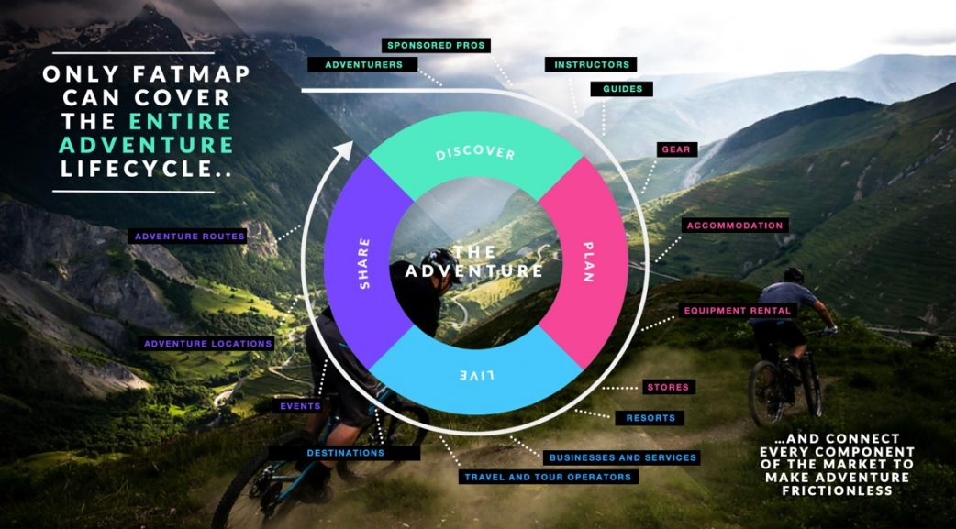  Image credit: Terrascope Ltd, Project :Fatmap  Describe in less than 200 words the objectives of the service, i.e. what are the key problems of the users, what is the solution you intend to provide and how will you provide it. Please describe also the objectives of the activity (Study or Project). Avoid the use of phrases like “The objective is to investigate the technical feasibility and economic viability...”. Restrict the use of acronyms and make sure there are spelled out at first occurrence.
Users and their needs | Describe in <200 words the user communities currently targeted, the users involved in the activity, or people who will be using the service/solution. Avoid extrapolating on “possible future users”. Define their needs and what are the challenges for the project to meet these needs. (Try to summarise the user needs, i.e. using a bullet list.).  Also indicate the country/countries of the targeted users.
Service/system concept | Describe in less than 200 words the capability or information supplied to the user, i.e. type of information that is delivered, specific features or functionalities, the capability the user will have when the service is deployed.  Also explain how the system works in simple terms (no jargon) for a wide audience. Explain the system architecture (on a high level). A simple diagram may be included but make sure it looks good. Don’t use serif fonts or font sizes which are too small to be readable.  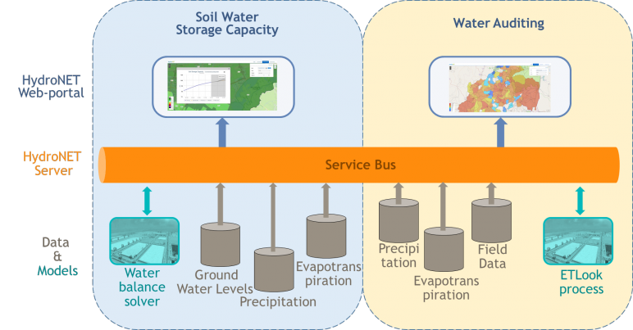  Image credit: Hydrologic, Project : Owasis
Space added value | Describe in less than 200 words which space assets are used, the expected added value of using and/or combining space assets to achieve the goals as opposed to using current methods from potential existing competitors.
Current status | Use photos, maps or screen grabs in this section. 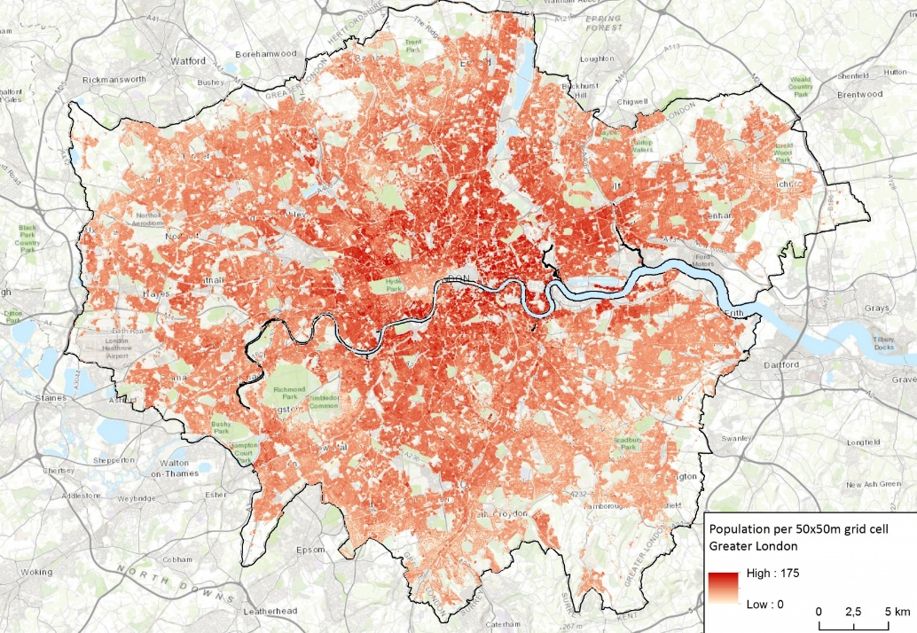  Image credit : Geoville, project Agespot  Describe in less than 150 words the status of the project. Avoid generic statements like “user requirements gathering” instead say “Held three workshops in different French cities, each one attended by 20 users”. Give a brief summary of achievements, work currently in progress and activities about to start.  The current status section should be updated when major project events are passed e.g. FAT test, SAT test.
Please continue to the page below ↓

→Project Web page template

Prime Contractor
Logo
Company Name | European Space Agency
Country | France
Website URL | https://www.esa.int/ESA

Sub Contractor 1
Logo
Company Name | European Space Agency
Country | France
Website URL | https://www.esa.int/ESA

Prime Contractor 2
Logo
Company Name | European Space Agency
Country | France
Website URL | https://www.esa.int/ESA

Related links – links to your product web page, news items or to ESA feasibility or Demo Project
Title | News story on BBC | URL | https://www.bbc.com/news
Title |  | URL
Title |  | URL

