[OUTLINE PROPOSAL TEMPLATE]
Please delete or replace blue text.
Note that your outline proposal should not exceed 20 pages.
- INTRODUCTION

  - Name
[What is the name of your idea]

  - Activity Type
[Indicate with an X whether you are submitting a proposal to run a Feasibility Study or Demonstration Project]

Activity Type | X where relevant
1: Feasibility Study with a proof of concept
2: Demonstration Project with a pilot

  - How did you become aware of this opportunity? e.g., LinkedIn, ESA website etc.

  - Relevant Topics: Please mark an ‘X’ indicating the pillar(s) that your service will address:

Topics of Relevance | Mark with ‘X’ where relevant
- Supporting the physical, emotional, psychological, social, or economic well-being of refugees and Internally Displaced Persons (IDPs).
- Supporting organisations to forecast, respond to, and manage humanitarian crises.
- Supporting communities hosting displaced people to adapt and respond to the challenges associated with migrant flows
- To support post-conflict recovery efforts
- Other (please explain)

  - Interest in Stakeholders: Please mark an ‘X’ indicating which (if any) of the stakeholders you would like ESA to connect you with.

Stakeholder | Mark with ‘X’ where relevant
- International Organisation for Migration (IOM)
- Institute for Economics and Peace (IEP)
- United Nations Children’s Fund (UNICEF)
- Norwegian Refugee Council (NRC)
- United Nations Satellite Centre (UNOSAT)

- SERVICE DESCRIPTION

  - Description of the service you intend to offer
[Describe the intended service here]

  - Key Benefits
[What economic, social and/or environmental benefits will your service bring?]

  - Key Partners
[Please present your key partners here e.g., do you have suppliers, manufacturers that you work with, business partners, etc.?]

  - Key Resources
[What are the most important assets to make your business model work, and do you already have access to them? e.g., access to Earth Observation data, manufacturing facilities, distribution networks, machines, Intellectual Property, experienced scientists, specific equipment, labs etc.]

  - Risks
[What are the main risks – technical and non-technical – to your study/project and to the future roll out of the service. What is the potential impact? Can you mitigate the risks?]

- USERS

  - Customers/Users and Stakeholders of the Service
[who will the users and/or paying customers be once your service becomes operational?]

  - User Engagement
[Please name and describe the specific customer/user organisation(s) and stakeholders that you plan to involve in this activity. Have you already engaged with any users/customers? If so, please explain your current level of engagement. Do you have any letters of commitment or emails expressing interest from possible users/stakeholders? If so, please attach them at the end of this proposal in the Annex. Please note that if you are applying for a Demonstration Project, you will need to include a letter of interest from at least 1 user by the Full Proposal stage.]

  - User Needs and Market Demand
[Please explain the key user/customer needs. What problems does the target market face? How will your service help solve/alleviate these problems? Can you quantify the problem(s) or solution(s)? Do you know the size of your target market?]

  - Key Channels
[Please clarify how you will reach out to new and existing users/customers during this study/project. How will you deliver your proof of concept or pilot to users during this study/project? How will you deliver your service to users in the future when the service becomes operational?]

- TECHNICAL POTENTIAL

  - Preliminary Technical Solution
[Please provide a technical diagram, which details the different elements of your service. The diagram should provide a bird’s eye view of the system components. Please explain the service outputs, and user interface and include initial technical requirements. Please highlight the space element(s) on the diagram.]
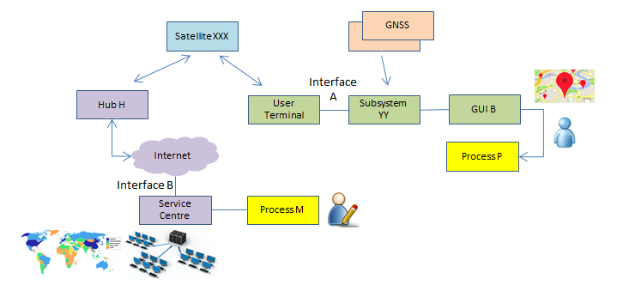
EXAMPLE

  - Involvement of Space Technology / Space Data
[Mark with an ‘X’ the space technology/technologies/data your service will use.]

Space Technology / Space Data | X where relevant
1: Satellite Communication
(Providing communication capabilities when ground-based networks are down, use of satellite phones, satellite IoT, etc.)
2: Satellite Earth Observation
(Remote sensing, weather satellites, etc.)
3: Satellite Navigation (Galileo, GPS, etc.)
4: Other (please explain)

[please explain the specific aspect of the space technology/technologies and/or data used e.g.,
- Satellite communication: bandwidth requirements, satellite communication operators involved, satcom application
- Satellite Navigation: accuracy, utilisation, navigation equipment to be used, providers
- Satellite Earth observation: optical/radar, spatial & temporal resolution, satellites/sensors, potential providers of the satellite Earth Observation data, access to the Earth observation data.]

  - Technology Maturity and Roll Out Plan:
[please describe the starting point of this activity e.g., starting from scratch, have an existing proof of concept, technical elements x and y have already been developed and tested etc. Provide a roadmap showing main milestones from current starting point to operationalisation]
e.g.,
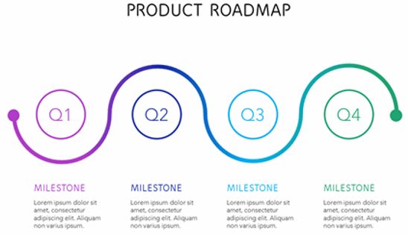
- WORK PLAN

  - Work Logic

[Present the planned work logic of the proposed Study/Project. Below are examples of proposed work logics for Feasibility Studies and Demonstration Projects. Please feel free to suggest alternative timelines or work logic, but note that a proof of concept must be included in a Feasibility Study and that the ‘pilot’ part of a Demonstration Project must begin by month 5.

Proposed work logic for a Feasibility Study is:

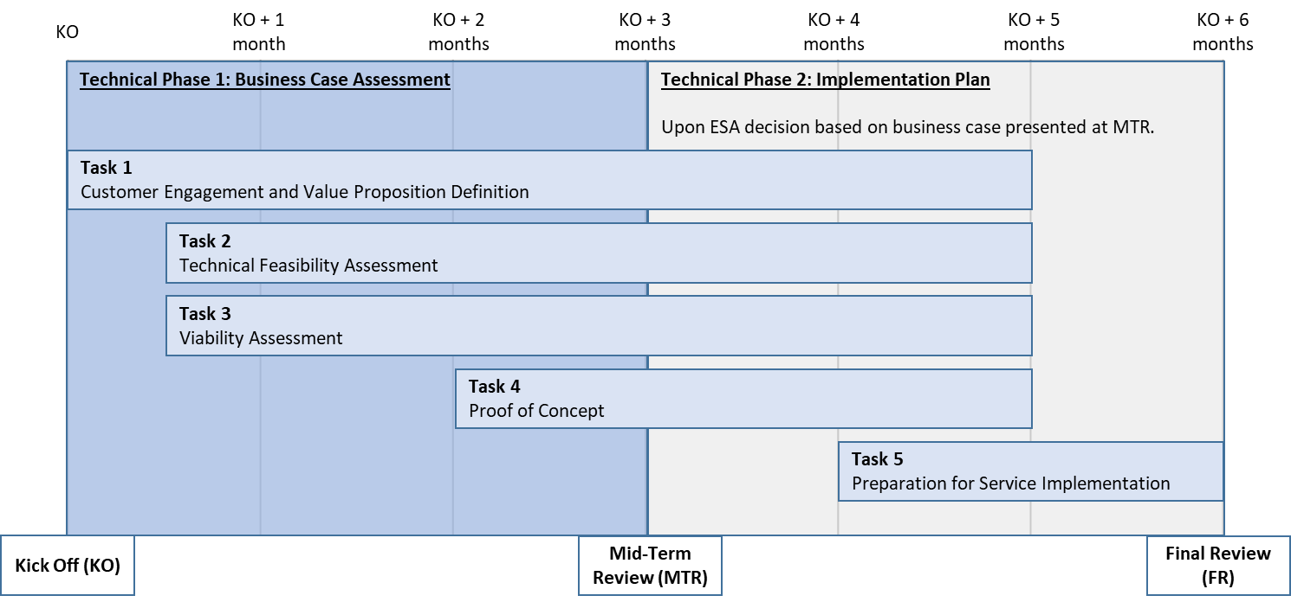

Proposed work logic for a Demonstration Project is:
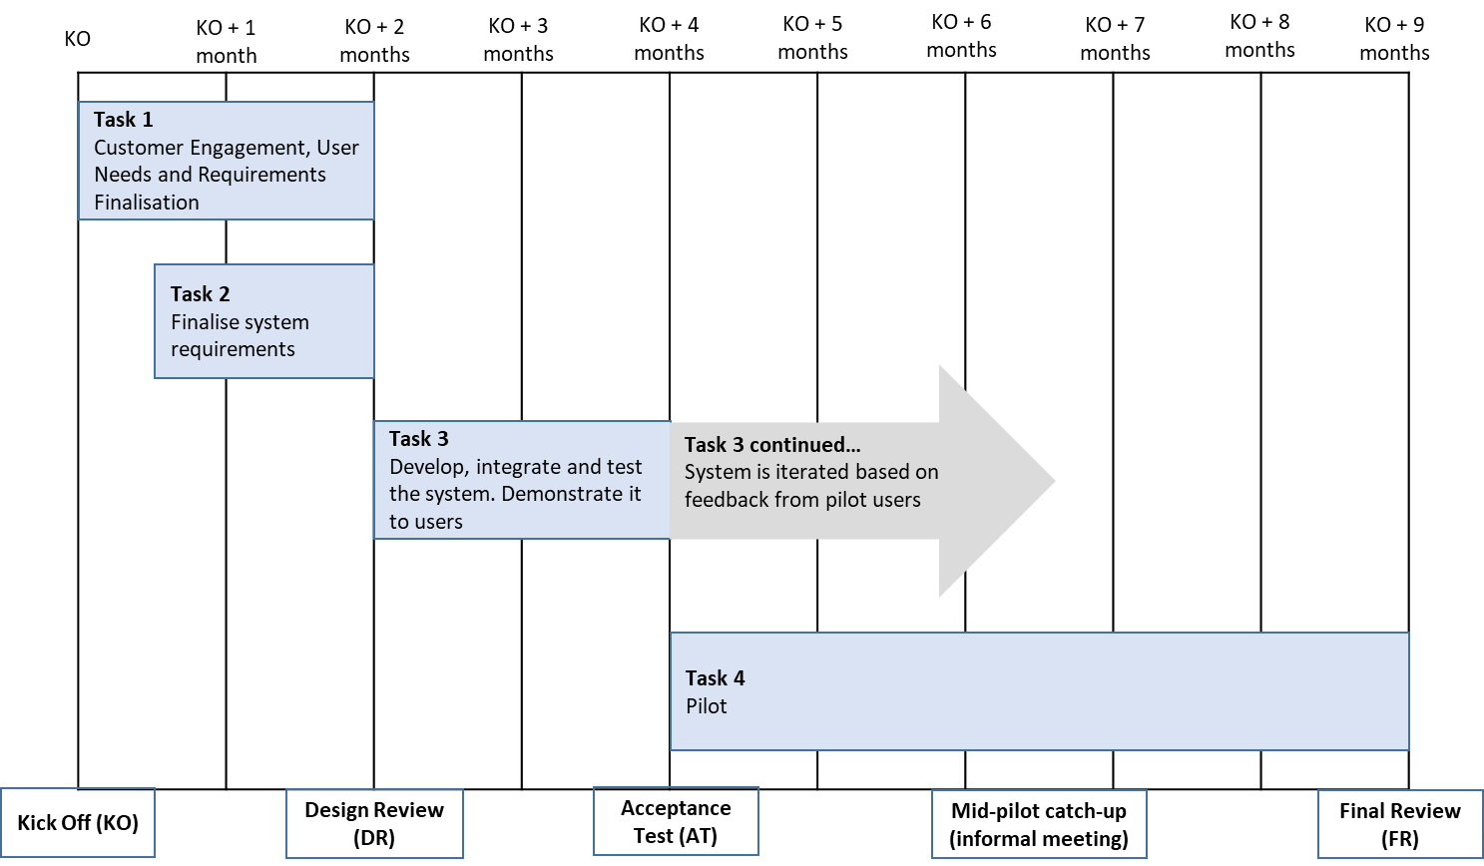

  - Planned Tasks

[Please provide a description of the work you intend to do during the study/project. Make sure to align the planned tasks in this table with the work logic in section 5.1]

Key tasks
Task | Key Activities | Responsible Company/Companies | Schedule
Task 1 | …….. | Prime | KO – KO+2 months
Task 2 |  | Subcontractor A
Task 3 |  | ………
Task 4

- STUDY TEAM

  - Company information
[Present the company(ies) involved in your team, including key company details such as turnover, number of employees, etc.]

  - Background and Experience
[Briefly describe relevant experience, if any, related to this study/project e.g., experience using the technologies involved, on other humanitarian projects etc. Explain the expertise that the company/companies in the team will bring]

  - Existing concepts / products relevant to this activity
[Briefly describe any existing products, technologies, services, concepts, intellectual property, patents, research papers, algorithms etc. relevant to this activity that have been previously developed by the team (if any).

  - Team Composition
[please present the key personnel (i.e. having a major role within the team and/or being responsible for one or more tasks) and their position in the company/organisation. For the nominated key personnel, please provide a paragraph outlining their experience relevant to the proposed activity.]

- FINANCIAL PART

  - Cost Breakdown

[Please provide information on the cost of this activity]

Breakdown cost and price for prime and subcontractor(s)
Company/ Organisation | Status  e.g., University, SME | Country | Cost  (kEUR)  (Should be A+B) | A.  ESA Price (kEUR)  [amount requested from ESA] | B.  Your contribution  (kEUR)  [Amount you will put into the activity] | % Funding from ESA | National Delegation Support
Prime | ……… | ……… | ……… | ……… |  | ……… | yes/no/  under discussion
Subcontractor 1 |  | ……… | ……… | ……… |  | ……… | yes/no/  under discussion
Subcontractor 2 |  | ……… | ……… | ……… |  | ……… | yes/no/  under discussion
TOTALS |  |  | TOTAL COST  XX kEUR | TOTAL ESA PRICE  XX kEUR

  - Source of Company Contribution
[Please provide information on how you will fund your contribution. Please clearly indicate the source of your contribution and the money available from this source.
The company contribution can be funded through private and/or public sector direct or indirect co-financing. Examples of possible sources of co-funding are existing funds in bank account coming from sales/profit, already approved/prospective bank loan, investment from external source e.g., private investment funds, other contributions.]

[END OF OUTLINE PROPOSAL TEMPLATE]

Please, note that work carried out by SMEs involved as contractors or subcontractors may be funded up to 80% by the Agency. The decision of the applicable funding level is with the related national delegation.
yes = The National Delegation has been contacted and is in favour of the proposed activity. no = The National Delegation has not yet been contacted. under discussion = The National Delegation has been contacted and discussions are ongoing.

